November 2020

KMC Notes
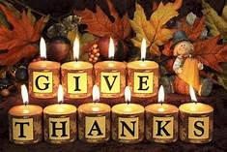
Save the Dates …
Indoor Worship Services
Sunday, November 1 (All Saints Sunday)
Sunday, November 8
Sunday, November 15 (November 13th Festival)
Sunday, November 22 (Thanksgiving Sunday)
Sunday, November 29 (First Sunday in Advent)

Annual Church Council
Sunday, November 15 (at end of our worship service)

ISAAC IS! HOW ABOUT YOU?
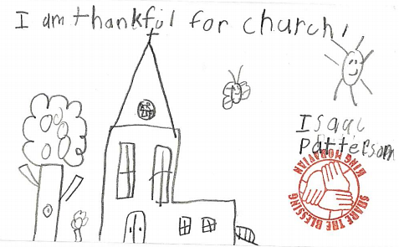
This past month during our Mission Blitz weekend, some of our members worked on our Church Office. They moved furniture, cleaned, organized shelves, labeled just about everything, and went through boxes and papers. The picture above is something one of the workers found with a note that said “Put this on the newsletter” which I agree is a great idea.

As you see in the picture, it was drawn by our own Isaac Patterson. Isaac is in his second year at The Citadel. I would say this is not a recent picture, but I would think Isaac would say the same thing about King Moravian.

In this month with its special emphasis on giving thanks, I hope each of us can join Isaac in being thankful for church and in particular this church. There are many things I’m thankful for about King Moravian. I’m thankful for the wonderful people who are make up this church family. I’m thankful that there are so many in our church who love the Lord and love this church. I’m thankful for the programs of our church such as our music program and youth program. I’m thankful for our outreach to others through our Mission Blitz to many homes in our community, our youth filling bags with birthday supplies for elementary students in our area, and our Circle of Joy raising funds for orphans at our Moravian School in Tanzania. I’m thankful that even though it’s been a tough year and we haven’t done everything we have hoped to do, I still have a good church family to help get me through this pandemic.

I am sure many of you join me in thanking God for His many blessings. I believe many of you also join me in knowing that our church family is one of God’s great blessings to us. As with any blessing God gives, the Lord wants us to do something good with it. It is my continued hope and prayer that each of us will do our part to make the most of the blessing of our church family so that we will continue to have a great church to be thankful for..
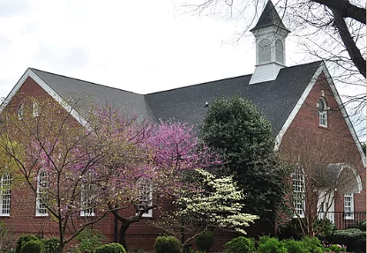
In Christ’s love and service,
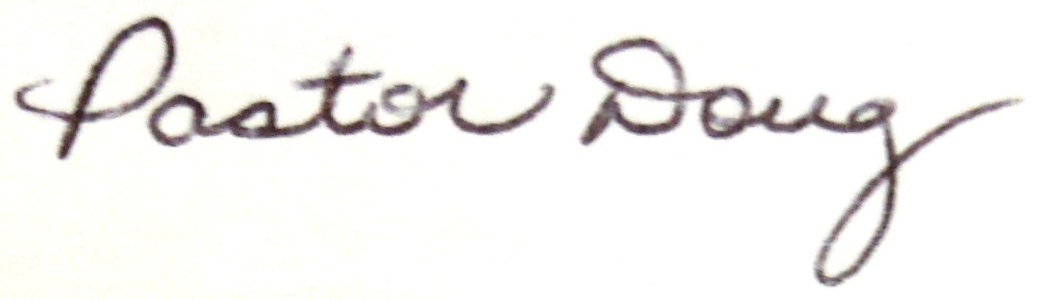

WELCOME TO THE NEWEST MEMBERS OF OUR STAFF

Leigha Davis Lee Christensen

Last month we announced that we have a new Church Treasurer, Lee Christensen. This month our Personnel Committee and Joint Boards are pleased to announce the hiring of our new Office Administrator, Leigha Davis.
Leigha and her husband, Nick, live in East Bend. They have a one-year-old daughter, Willah. Leigha is originally from Burlington. Even though Leigha is new to our church family, she is not new to everyone. She and our Director of Christian Education, Rachael Butts, worked together at Van Davis Aveda in Winston-Salem where Rachael saw firsthand how Leigha was capable of doing a great job as our Office Administrator.
Lee and her husband, Rod, live in Clemmons. They have two children, Ben (age 19) and Chloe (age 17). Lee is also originally from Burlington. As mentioned in last month’s newsletter, Lee is not new to our church family. She has serviced our church before as our Church Treasurer. We thank her for the wonderful job she is doing for our congregation.
If you need to get in touch with Leigha or Lee, please call the church office at (336) 283-5322. You can also email Leigha at office@kingmoravianchurch.org and Lee at kmctreasurer1@gmail.com.

SPECIAL SERVICES AND EVENTS IN NOVEMBER

INDOOR SERVICES BEGIN SUNDAY, NOVEMBER 1
Our Task Force that plans our services during the coronavirus had decided that due to the upcoming colder weather we want to begin having our worship services indoors beginning Sunday, November 1, at 11:00 a.m. For our indoor services, our Task Force has set up the following safety precautions:
● We will have air purifiers which will purify the air our narthex and sanctuary. We are
using air purifiers that kill over 99% of the coronavirus.
● Everyone will need to wear a mask or face covering. If you do not have one, we will
have one available for you.
● Families and individuals will be seated with proper distancing and everyone is asked
to practice social distancing throughout your time here.
● There will be no childcare available (we look forward to the time when we can provide
childcare).
If you have any questions about our services, you are more than welcome to contact any of our Task Force members who are Jennifer Dunn, Drake Flynt, Rachael Butts, Darrell Goins, Dane Heath, Ken Lyda, Holly Mathis, Desty McEwan and Doug Rights.

ALL SAINTS SUNDAY – SUNDAY, NOVEMBER 1
On Sunday, November 1, our worship service will have an All Saints emphasis as we remember God’s faithful servants and witnesses who have gone to be with the Lord. On that Sunday everyone’s bulletin will include an insert with the names of our members who have passed away (our All Saints of King Moravian). With November 1 being the first Sunday of the month, we will also receive a special offering for King Outreach Ministry.
Also, please make sure you move your clocks back one hour as we go back to Eastern Standard Time.

NOVEMBER 13th FESTIVAL OF THE MORAVIAN CHURCH
SUNDAY, NOVEMBER 15
On Sunday, November 15, we will celebrate the November 13th Festival of the Moravian Church. On November 13, 1741, an announcement was made to all Moravian churches that Jesus Christ is the Chief Elder of the Moravian Church. This was a time when the Moravian Church recognized Jesus Christ as the head of the church in a special way. Part of our observance of this important date in our church’s history will include the celebration of Holy Communion.

ANNUAL CHURCH COUNCIL – SUNDAY, NOVEMBER 15
At the end of our worship service on Sunday, November 15, we will have our annual Church Council meeting. At our Church Council there will be the opportunity to ask any questions about our church reports which will be sent out before the meeting. We will also elect new members to our Board of Elders and Board of Trustees. We will see our budget for the new year.
At this time our nominees for Elders and Trustees are the following:
Board of Elders
Desty McEwan (currently on the Elders and can be reelected)
Jerry Saunders
Board of Trustees
Gina Handy
Cathy Saunders
We would like to have other nominees since we have three positions to fill for each board and we are stilling seeking someone to serve a two-year term on our Elders. We will also receive nominations at our Church Council. If you would like to be a nominee, please contact someone from our Nominating Committee who are Jennifer Burge-Carter, Desty McEwan, Becky Patterson, Shiela Patterson, Andi Sells, or Janie Young. If you would like to nominate someone, please make sure that person is willing to be nominated.

THANKSGIVING SUNDAY – SUNDAY, NOVEMBER 22
On Sunday, November 22, we will have our Thanksgiving Sunday as we thank God for His many blessings in our lives and in the life of our church. Our service this Sunday will include a lovefeast,

SPECIAL THANKSGIVING FOOD OFFERING FOR KING OUTREACH MINISTRY
SUNDAY, NOVEMBER 22
On our Thanksgiving Sunday we will receive a special food offering which will go to King Outreach Ministry. Please bring canned goods and nonperishable food products when you come to church on this particular Sunday which we will collect at the front of the sanctuary.

CHURCH WORK DAY – SATURDAY, NOVEMBER 7
There will be a Church Work Day on Saturday, November 7, at the church. The purpose of the Work Day is to remove the trees behind the Picnic Shelter. Through the years the trees have become a hazard for their growth above ground and from their roots below ground that have affected the floor of the Picnic Shelter. If you have any questions about the Work Day, please contact Corky Newsome or Robert Simpson.

SPECIAL WORDS OF THANKS
We thank everyone who made this past month’s Mission Blitz a great success! We have eleven homes in our area that are very thankful for the work done. Thank you to everyone who worked, who gave money and food, and who prayed. Special thanks to our Share the Blessing Committee for all their planning. The committee this year is Paula Hall, Desty McEwan, Amy Reeves, Robert Simpson, Ken Sevier, Zollie and Renee Smith, and Doug Rights.

CHURCH FAMILY NEWS

Congratulations to Patrick and Erica Nail upon the birth of their son, Logan Ryan Nail, on Saturday, October 24. Logan’s grandparents are Gary and Amy Nail and Dwayne and Tina Pratt.

Congratulations to Stanley Gordon and Kathy Leighton who were united in marriage on Saturday, October 24.

In the hospital since our last newsletter have been Ken Campbell, Hughes Gentry, Freddie Johnson, Bonnie Tomchik, and Erica and Logan Nail.

Please continue to pray for all health care workers and for those in our church family who are Kathy Anderson, Chelsea Boaz-Edmonds, Daphne Brendle, Beth Donnelly, Sarah Doby, Lynn Enswiller, Grayson Finn, Mallory Finn, Lacey Grubbs, Kim Hall, Tyler Hill, Rhonda Huff, Robin Kincaid, Dottie Jones, Tim and Lori Justis, Scott and Ticia Kribbs, Diane Marion, Lindsay Naparano, Sara Russell, Andrea Seckman, Gale Stone, Kevin and Barbara Sudol, Jessica Wall, Taz Whitt, Myra Wright and Janie Young.
Also, there are several in our church family who would like for us to pray for their family members who are health care workers who included Kristine Santiago (Kathy Anderson’s sister), Sherre Johnson (Eric and Sandy Emery’s daughter), Robin Williams (Jerry and Cathy Saunders’ daughter), Taylor Newsom (Fran Newsom’s niece) and Noelle Redmon (Bill and Nan Pulliam’s daughter).

Please pray for the school teachers and school personnel as they have started a new school years in the midst of the pandemic. Those from our church family are Shannon Anderson, Candice Covington, Jay and Emily Duncan, David and Patti Durham, Jenn Harper, Jenny Key, Holly Mathis, Gary and Amy Nail, Patrick and Erica Nail, Kelly Nickel, Becky Patterson, Shiela Patterson, Amy Reeves, Anna Russell, Jennifer Shore, Leah Simpson and Nancy Witt. Please pray for our church’s Preschool and our Preschool Director, Tina Pratt, and our Preschool Teachers as they prepare for their upcoming year of Preschool. Also pray for all our students.

YOUTH FELLOWSHIP NEWS
This past month our Senior Highs, Middle Highs and Juniors had their Birthday Party in a Bag projects for elementary students in our community who might not have their own birthday party. Special thanks to everyone who donated items and funds for the bags. Our youth were able to make over 125 bags which were given to King Elementary, Mount Olive Elementary, and Poplar Springs Elementary.

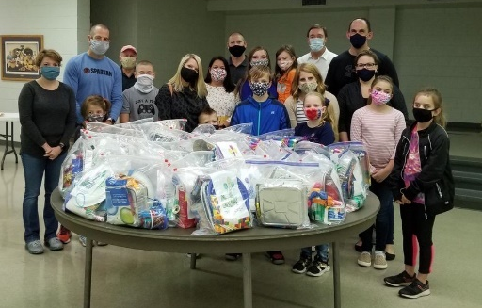

OTHER SENIOR HIGH AND MIDDLE HIGH NEWS
Our Senior Highs and Middle Highs also went to a spooky corn maze this past month.

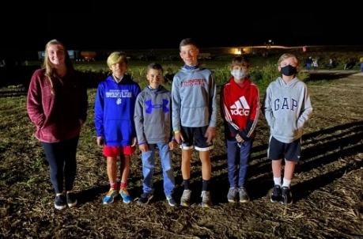

This month our Senior Highs and Middle Highs are doing the following:
Wednesday, November 4 Meetings at the church
Saturday, November 7 Tree Planting Ceremony in memory of Walt Justis
Wednesday, November 18 Meetings at the church

TREE PLANTING CEREMONY IN MEMORY OF WALT JUSTIS
Our Senior Highs invite everyone to a tree planting ceremony in memory of Walt Justis on Saturday, November 7, at 10:00 a.m. at the playground. Walt passed away earlier this year. Our Senior Highs would like to remember him in this special way as they will plant a white oak tree along the outer gate of the playground.

OTHER JUNIOR NEWS
Our Juniors also got together this past month after church to roast hot dogs, talk about Creation, and spend an afternoon at The Farm in Dobson.

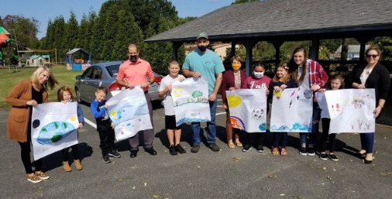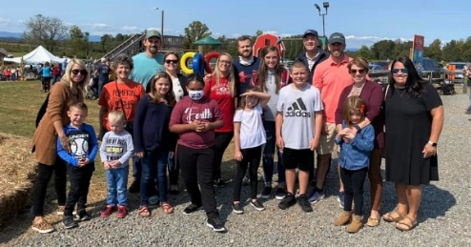

This month our Juniors are doing the following:
Friday, November 6 Movie Night and Dinner at the church
Sunday, November 22 Study on the Moravian Church

Financials

Offerings received through October 31st: $276,131.40
Budget expenses through October 31st: $272,601.46
2020 monthly contribution for shared Moravian Church Ministries: $4,772 per month has been paid through November.

November Birthdays
2- Doug Rights  3- Joni Boaz  5- Henry Bowman  5- Hailey Thomas  6- Ethan Harper  6- Don Jennings  7- Anna Russell  9- Kevin Newsome  9- Doug Spainhour  11- Larry Boles  11- Ken Sevier  11- Geoff Gentry  12- Anna Grubbs  14- Victoria Smith  17- Isabella Watson | 20- Taz Witt  20- Keely Finn  22- Nicole Newsome  23- Ken Lyda  23- Gordon Grabs  25- Nate Hundley  26- Andi Sells  27- Austin Key  27- Doug Jones  28- Kathy Rights  28- Kent Wall  30- Doris Rutledge  30- Louise Cape  30- Rhonda Huff

CHURCH SCHEDULE FOR NOVEMBER

November 1 Indoor Worship Service – All Saints Sunday (11:00 a.m.)

November 6 Juniors – Movie Night at the church (7:00 p.m.)

November 4 Senior Highs and Middle Highs meetings at the church (6:00 p.m.)

November 7 Church Work Day to remove trees behind Picnic Shelter (8:00 a.m.)

Tree Planting Ceremony by our Senior Highs in memory of Walt Justis
at the playground (10:00 a.m.)

November 8 Indoor Worship Service

November 10 Joint Board meeting (6:30 p.m.)

November 15 Indoor Worship Service – November 13th Festival (11:00 a.m.)

Annual Church Council (end of worship service)

November 18 Senior Highs and Middle Highs meetings at the church (6:00 p.m.)

November 22 Indoor Worship Service – Thanksgiving Sunday (11:00 a.m.)

November 26 Church Office closed for Thanksgiving holiday

November 27 Church Office closed for Thanksgiving holiday

November 29 Indoor Worship Service – First Sunday in Advent (11:00 a.m.)

KMC is happy to organize a Meal train for members and friends of the church community!
Please contact Rachael Butts at rachsb94@gmail.com or office@kingmoravianchurch.org

PROGRAM FOR FREE WILLS FOR OUR CHURCH MEMBERS
We are now able to offer our members a free service where you can have a free will, a free power of attorney, and/or a free healthcare power of attorney. We are doing this through GiftWise which is a division of Momma Bear Legal Forms. For those who would like to use this service, you can access the King Moravian site at the following link:
http://www.giftwise.com/kmc
We thank everyone who filled out the survey who expressed an interest in our providing this service. We also thank our Board of Trustees for their approval. If you have any questions about this program, please contact the church office or Pastor Doug.

SOME PRESCHOOL PICTURES

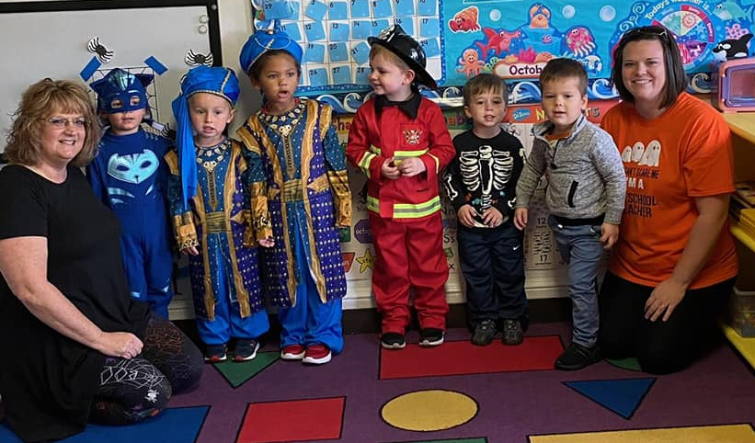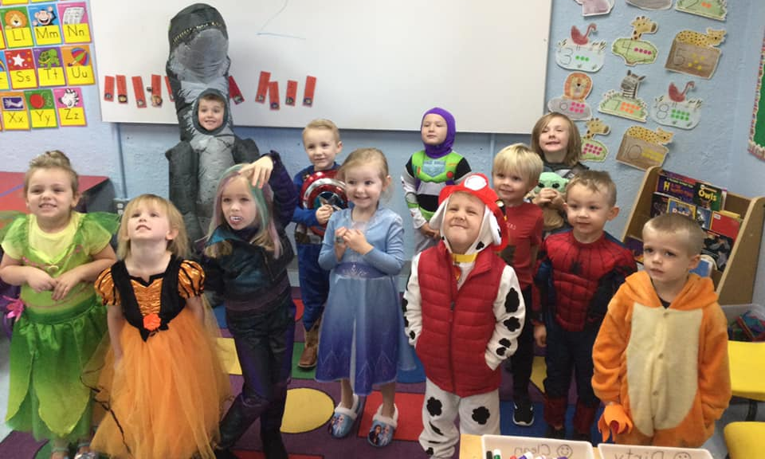

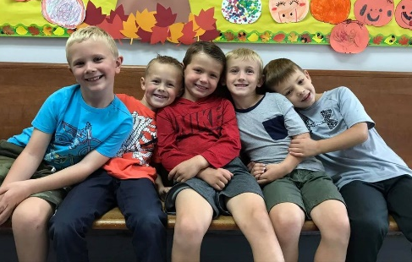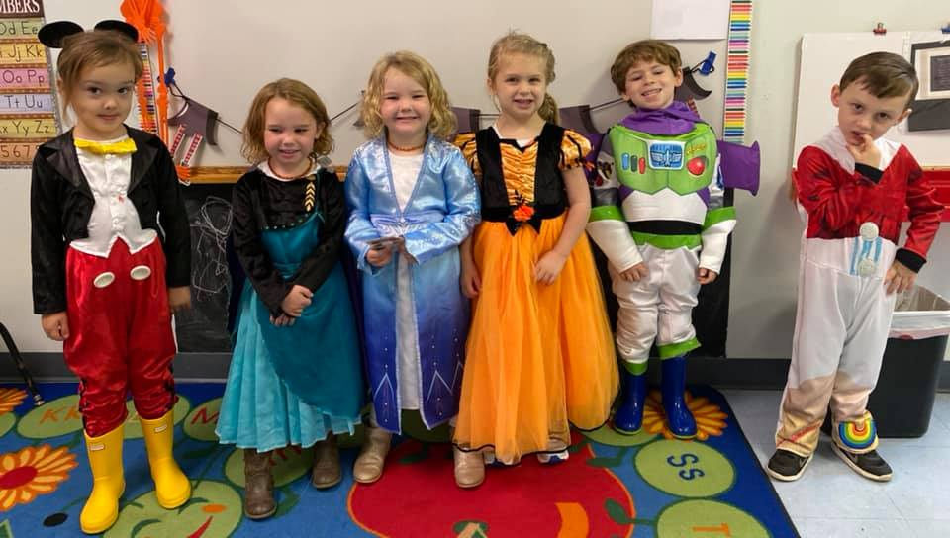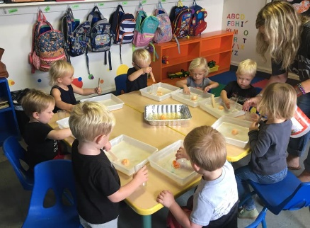

Pray Every Day October 2020
(A list of daily prayer concerns from our Board of World Mission)

- Sunday-All Saints Day-Send out your light and your truth ; let them lead me. Pray for Michael and Brenda Brent in Croatia
- All have sinned and fall short of the glory of God. Pray for Charlie and Vickie Brent in Texas.
- Rejoice with Jerusalem and pray for her. Pray for Safiatu Braima in Serria Leone
- Jesus Christ is the atoning sacrifice for our sin.Pray for Moravians in Peru.
- You are all children of promise.Pray for the Theisens in Mexico.
- May the Lord direct your heart to the love of God. Pray for the Teshes in Kenya
- Become imitators of those who through faith and patience inherit the promises. Pray for Alas de Socorro in Honduras.
- Sunday-Keep awake for you know neither the hour nor the day. Pray for Armando Rusindo Foundation and Cuba.
- A person is justified by faith , not by works. Pray for Justin Rabbach (BWM).
- God will satisfy your needs according to His riches in glory in Jesus Christ. Pray for the Sineaths in Campus Outreach.
- What good is it to gain the whole world yet forfeit ones soul. Pray for Annie B Missions(Star Mt) Palestine
- Let us continually offer a sacrifice of praise to God. Pray for Steve &Ann Marx (MAF).
- I will pour my spirit upon your descendants. Pray for the Harrisons with Greek University.
- How great are your works, O Lord. Pray for Unity Womens Desk.
- Sunday-Persue righteousness, faith, love and peace. Pray for the Hoffmans in HIV/AIDS Ministry.
- Love your neighbor as yourself. Pray for Brian and Heather Marx (MAF).
- God saved us and called us with a holy calling. Pray for Jenna and Andrew Craver in Alaska.
- We must obey God over human authority. Pray for Alan and DeeDee Iobst in France.
- O taste and see that the Lord is good. Pray for Kevin and Charity in the Middle East.
- He changes times and seasons, deposes and sets up kings. Pray for Dr. Benno and Teresa Marx.
- God, your steadfast love is better than life. Pray for Moravian volunteer efforts.
- Sunday-I am the Lord and beside me there is no savior.P ray for Adopt A Village in Tanzania
- Jesus had compassion on them as they were like sheep without a shepherd. Pray for those still suffering loss due to disasters.
- All the ends of the earth have seen the salvation of our God. Pray for Moravian ministers and for churches needing them to bring God’s word.
- Command those who are rich not to be haughty. Pray for the food programs taking care of those needing good nutrition.
- Give thanks to God and praise His name. Pray that our country will turn back to God
- The testing of your faith produces endurance. Pray for all those suffering from the COVID-19 virus.
- Because I live, you will live. Pray for the leaders of our churchs and our country
- Sunday-His mercy is for those who fear Him from generation to generation. Pray for medical personnel serving in the war against Covid-19.
- It is God who justifies. Pray for Police and Fire fighters everywhere.

KMC Notes
November 2019
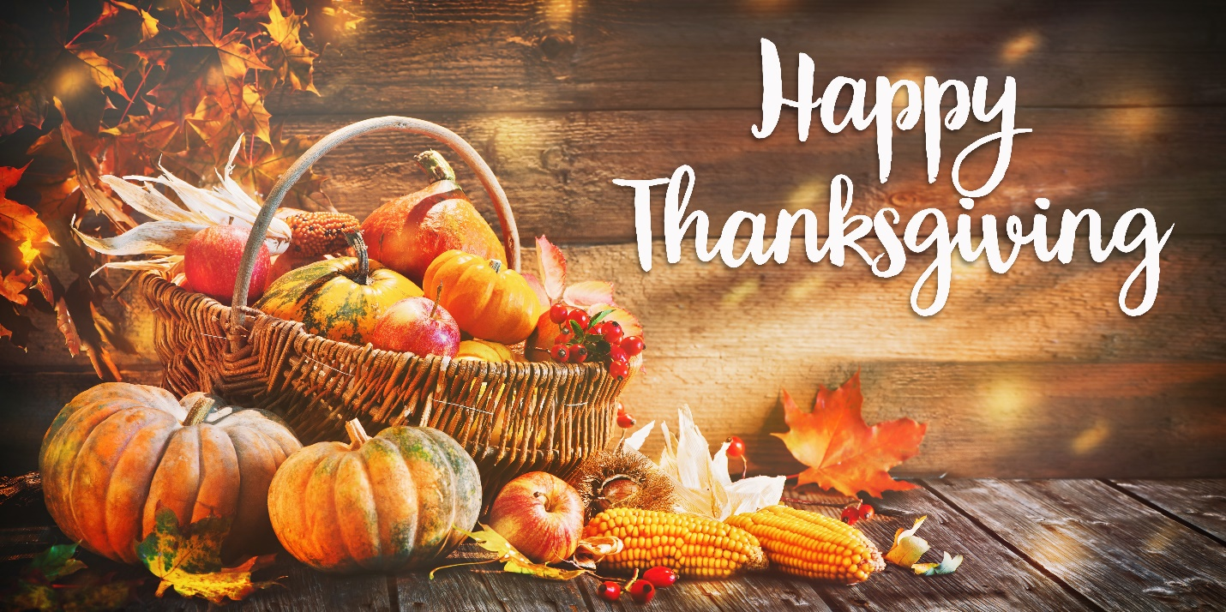

King Moravian Church
228 West Dalton Rd.
King, NC 27021

