June 2021

KMC Notes
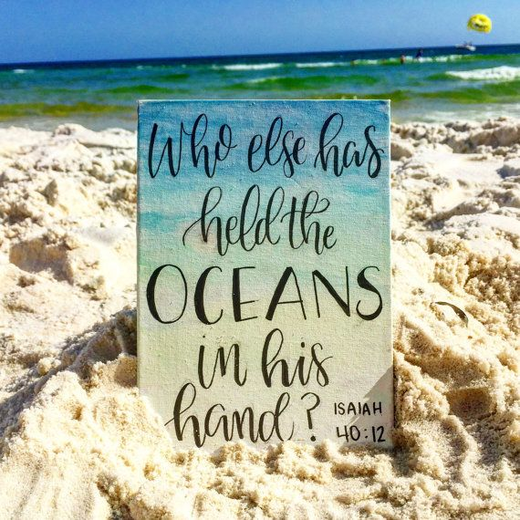
Save the Dates …
We hope you will join us for our
Worship Services

Sunday, June 6 First Indoor Service!
(Second Sunday after Pentecost)

Sunday, June 13 (Third Sunday after Pentecost)

Sunday, June 20 (Father’s Day)

Sunday, June 27 (Fifth Sunday after Pentecost)

A GREAT SUMMER AHEAD!

I am looking forward to this summer! I look forward to moving on from the coronavirus. I look forward to getting out more. I look forward to some time away, and this year not be as worried about being away from home.

I am also looking forward to many things this summer at King Moravian. I look forward to having our own Ethan Smith serving as a Summer Intern for our church family. Ethan’s internship is part of his college studies as he is majoring in Religion at Appalachian State. His internship is also an opportunity for him to share his deep love for the Lord and his love for our church family with us. I look forward to getting back into our sanctuary on Sunday mornings for our worship services. I will admit that I have enjoyed our Outside Worship Services. God has blessed us with a wonderful outdoor setting on our front lawn to worship Him. Yet once we are inside, we do not have to deal with the noise of motorcycles and loud mufflers and bugs, the uncertainty of the weather, and the wind that can blow envelopes out of the offering plates and topple flower vases and blow my notes off the lectern. I look forward to seeing what suggestions people have for my “You Asked for It” series of messages and I look forward to working on the topics. I look forward to golf on Tuesday afternoons with some of our church members. I look forward to having children at the church this year for our Vacation Bible School. And I look forward to being with some of our youth and adults at this summer’s Middle High Camp at Laurel Ridge.

I hope you are looking forward this summer. I hope you’re looking forward to getting out more than you did this past summer. I also hope you’re looking forward to being with us at King Moravian as much as you can this summer. It is always great to see you when you are at church, and we miss you when you are not here. I’m thankful that whether you are here or not, you can still keep in touch with what’s happening through our online services and our church communications such as this newsletter. I believe we have a lot to be thankful for in our church family. I also believe the more people who are involved in our church, the more we have to be thankful for.

This past month for some of our worship services, I talked about what it takes to have an awesome family. What it takes to have an awesome family are also the same things it takes to have an awesome church family. The traits I shared for an awesome family are:
● An awesome family has fun.
● An awesome family encourages growth.
● An awesome family protects each other.
● An awesome family serves God and others.
I hope you will join me this summer and beyond to be committed and intentional to be an awesome church family that has fun, that encourages growth, that protects each other, and that serves God and others. As we do, I believe we will have a great summer! I believe we will continue on and have a great year! I believe we will go beyond this year and continue to share a great legacy! I look forward to it!

In Christ’s love and service!

SPECIAL SERVICES AND EVENTS IN JUNE

INDOOR WORSHIP SERVICES BEGIN SUNDAY, JUNE 6!
WALK UP OFFERING FOR KING OUTREACH MINISTRY
On Sunday, June 6, we return to our sanctuary for our worship services! Our service will be at 11:00 a.m. With it being the first Sunday of the month, our service will include our Walk Up Offering for King Outreach Ministry.
Our Task Force that has planned our worship services during COVID will meet this week. Please see our other church communications for any information about any of the restrictions there may be for our indoor services. We are very thankful for our Task Force that has helped navigate our church family through this past year. We thank them for their decisions to keep things going and to provide the safest way for us to continue. The members of our Task Force are Rachael Butts, Jennifer Dunn, Drake Flynt, Darrell Goins, Dane Heath, Ken Lyda, Holly Mathis, Desty McEwan, Barbara Sudol and Doug Rights.
If you want to come and just worship from your vehicle, we’ll continue to use our FM transmitter. We will also continue to show our services online which include Facebook Live as they happen and recordings of the service on our Facebook page, our church’s YouTube channel, and our church website.

FATHER’S DAY SUNDAY – SUNDAY, JUNE 20
We celebrate Father’s Day on Sunday, June 20. During our worship service we will recognize and honor all of our fathers. Also, on this Sunday our Summer Intern, Ethan Smith, will bring the message.

SUMMER SERMON SERIES – “YOU ASKED FOR IT” STARTS
SUNDAY, JUNE 27
During the summer months, Pastor Doug will preach a series of messages called “You Asked for It”. Doug would like to know what topics or Scripture passages you would like to hear a message on. If you have an idea for a message, there is a place in the Sunday bulletins that you can make your suggestions. You can also email suggestions to Doug at doug@kingmoravianchurch.org.
Besides ideas for messages, Doug would also like to get your “You Asked for It” hymns and songs. If there are any particular hymns or songs you would like to sing during our worship services during the summer, please let Doug know.

LOOKING FOR PEOPLE TO HELP
As we get back to worshipping in our sanctuary, there are some ways we need some people to help with the following:

AUDIO VISUAL TEAM
When we return to our sanctuary for our worship services, we want to continue to show our services online. At this time, we are looking for those in our church family who would like to work with the audio and video for our services. If you are interested, please let Dane Heath or Pastor Doug.

FLOWER CALENDAR
We appreciate those who provide flowers for our services. At this time, we have a lot of openings on our Flower Calendar. If you would like to provide flowers for our services, please sign up on our Flower Calendar which will be in our Narthex or call the church office. If you have any questions about our Flower Calendar, please contact Ann Lawrence.

GOLF ON TUESDAYS
We are offering opportunities for anyone who would like to get together to play nine holes of golf at the Pilot Knob Golf Course on Tuesdays throughout the month of June. If you would like to play, please meet at the course at 5:30 p.m. If you need to come later, that’s all right. Pilot Knob is offering us a reduced rate of nine holes plus cart for $20 and nine holes if you walk for $13. If you have questions or need more information, please contact Pastor Doug.

ARCHIVES PROJECT CONTINUES ON WEDNESDAY AFTERNOONS
We thank everyone who has helped with our Archives Project these past months. There is just a little more to do. If you would like to help, please come to the church office on Wednesday afternoons at 1:30. For more information, please contact Rachael Butts at rachsb94@gmail.com.

BLOOD DRIVE – WEDNESDAY, JUNE 30
Our church will sponsor another Red Cross Blood Drive on Wednesday, June 30, from 1:00 p.m. until 5:30 p.m. If you would like to sign up to give blood, please go to the Red Cross website. We are also looking for people who would like to provide refreshments and help sign people in. If you can help or have any questions about the Blood Drive, please contact Scott Cardwell.

CONGRATULATIONS TO OUR GRADUATES!

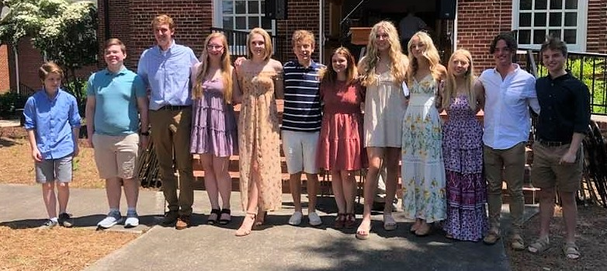

On Sunday, May 23, we had our Graduate Sunday as we honored our high school graduates. Special thanks to Shiela Patterson and Rachael Butts for the wonderful job they did in recognizing our graduates. We also thank our Circle of Help for the gifts they had for each graduate. This year’s high school graduates are:

Cole Cardwell
Cole is a graduate from West Stokes High School. He is the son of Scott and Tracy Cardwell. Cole will attend Appalachian State University this fall.

Rachel Durham
Rachel is a graduate from West Stokes High School. She is the daughter of David and Patti Durham. Rachel will attend Appalachian State University this fall.

Delaney Finn
Delaney is a graduate from West Stokes High School. She is the daughter of Diane Marion. Delaney will attend Leon’s Beauty School.

Morgan Goins
Morgan is a graduate from Stokes Early College High School. She is the daughter of Darrell Goins and Myra Wright. Morgan will attend the University of North Carolina at Chapel Hill this fall.

Chloe Hooker
Chloe is a graduate from West Stokes High School. She is the daughter of Ben and Brandi Hooker and Pam Crigger. Chloe will attend the University of North Carolina at Charlotte this fall.

Nate Hundley
Nate is a graduate from West Stokes High School. He is the son of Russ Hundley and Rodney and Kelly Norman. Nate will attend the University of North Carolina at Greensboro this fall.

A.J. Moran
A.J. is a graduate from West Stokes High School. He is the son of Tracy and Susan Moran. A.J. will attend the University of North Carolina at Chapel Hill this fall.
Nicole Newsome
Nicole is a graduate from West Stokes High School. She is the daughter of Kevin and Michelle Newsome. Nicole will attend Wingate University this fall.

Lucey Patterson
Lucey is a graduate from South Stokes High School. She is the daughter of Randall and Shiela Patterson. Lucey will attend the University of North Carolina at Charlotte this this fall.

Tyler Patterson
Tyler is a graduate from South Stokes High School. He is the son of Britt and Becky Patterson. Tyler will attend Virginia Tech University this fall.

Nate Sapp
Nate is a graduate from West Stokes High School. He is the son of Kim Grabbs. Nate will attend the University of North Carolina at Chapel Hill this fall.

Russell Sapp
Russell is a graduate from West Stokes High School. He is the son of Kim Grabbs. Russell will attend North Carolina State University this fall.

Sarah Grace Sells
Sarah Grace is a graduate from West Stokes High School. She is the daughter of George and Andi Sells. Sarah Grace will attend Appalachian State University this fall.

Anna Grace Smith
Anna Grace is a graduate from West Stokes High School. She is the daughter of Richard and Kristin Smith. Anna Grace will attend Belmont Abbey College this fall.

We also had flowers at our Graduate Sunday which were given by our church family in memory of Walt Justis who would have graduated this year. Please keep the Justis family in your prayers.
We also congratulate our recent college and graduate school graduates who are:

Omnie Grabs
Omnie graduated from Appalachian State University with a Bachelor’s of Science in English with a Secondary Education concentration. Omnie will start his Masters in Reading and Literature at Appalachian State this month. He is the son of Kip Grabs and Paula Hall.

Alli Nickell
Alli finished her graduate degree from Virginia Tech University. She is the daughter of Paul and Kelly Nickell.

Sara Russell
Sara graduated from Western Carolina University with a Bachelor of Science in Nursing. She is the daughter of Randy and Ashley Russell.

CONGRATULATIONS TO THE RECIPIENTS OF OUR CHURCH SCHOLARSHIPS
King Moravian Church is proud to announce the 2021 scholarship recipients of our church’s Brandon and Booe Scholarships. The recipient of the Brandon Scholarship is Nicole Newsome. She is the daughter of Kevin and Michelle Newsome and plans to attend Wingate University in the fall. The recipient of the Booe Scholarship is Dunivant Grabs. She is the daughter of Kip Grabs and Paula Hall and is a student at Appalachian State University.
Congratulations to these well-deserving members of King Moravian Church.

CHURCH FAMILY NEWS

Congratulations to Tom Langan and Jennifer Reeves were united in marriage on April 30.

Our church family extends its Christian love and sympathy to Britt Patterson and his family upon the passing of his mother, Dot Patterson, on May 7, and to Budge Gage and his family upon the passing of his daughter-in-law, Carol Gage, on May 13.

Congratulations to Cole Cardwell who was selected to the Boys’ All-Conference Tennis Team and to Anna Grace Smith to the Girls’ All-Conference Volleyball Team. Both Cole and Anna Grace are students at West Stokes High School.

In the hospital since our last newsletter have been Eddie Harper, John Matthews, Pat McGalliard, Gina Handy and Roger Cooke.

SPECIAL WORDS OF THANKS

We thank Annie Liss for her sharing at our Mother’s Day Service about her and her husband, Louise’s, ministry in Lebanon. Annie is the granddaughter of Ray Horner. If you would like to learn more about their ministry and if you would like to learn more about how to sponsor a child at their School of Hope, please check the following links:
The link for the Horizons International Lebanon Crisis Project is:
https://docs.google.com/presentation/d/1Y9Kh5myfKv63jxAjUkh6mB3akWHtISSNtDsSaXZVQlE/edit?usp=sharing
The giving link for Louis and Annie is (they are on the dropdown as STAFF – Louis & Annie Liss):
https://www.horizonsinternational.org/three-ways-to-give
The link to sponsor a child at the School of Hope is:
https://www.horizonsinternational.org/school-of-hope

We thank those who have helped with our Outdoor Worship Services these past two months. Special thanks to Ken Lyda who made sure everything was set up and who worked our sound system. Special thanks also to those who provided all the great music for the services who included Drake Flynt, Jennifer Dunn, Russell Sapp, Annette Covington, Kim Grabbs, Ann Lawrence and Desty McEwan. Special thanks to Kathy Rights for filming the services. Thank you to everyone who has worked on our Prayer Garden this year which has helped make our front lawn a beautiful place to worship.

We thank Kevin Newsome and those who worked with him to replace some of our sidewalk in the front of the church where it was not level.

VACATION BIBLE SCHOOL
TUESDAY, JULY 6 – FRIDAY, JULY 9
KMC is happy to announce we will be doing in person VBS this year! Our Vacation Bible School will be Tuesday, July 6, through Friday, July 9. The theme for this year’s VBS is “To Mars and Beyond! Together we can Go Beyond with Faith, Go Beyond with Boldness, and Go Beyond with Thankfulness!” If you have any questions, please contact Rachael Butts for more information rachsb94@gmail.com. The link for the registration is:
https://docs.google.com/forms/d/18bU52JNdIA5XlhDFVLa7LbhZRuM3LrO6u-cyDwVlVIs/viewform?edit_requested=true

CHURCH SCHEDULE FOR JUNE

June 1 Golf at Pilot Knob at 5:30 p.m.
(Every Tuesday evening in June)

June 6 First Indoor Worship Service at 11:00 a.m.
Juniors – End of Year Pool Party after church

June 8 Joint Board Zoom Meeting at 6:30 p.m.

June 13 Worship Service
Senior Highs and Middle Highs – Slip and Slide at 5:30 p.m.

June 20 Worship Service at 11:00 a.m.

June 21 King Moravian Preschool Summer Fun Begins – 9:00 a.m. to
1:00 p.m. (Monday through Friday)

June 27 Worship Service at 11:00 a.m.

June 30 Blood Drive in Fellowship Hall – 1:00 p.m. – 5:30 p.m.

YOUTH FELLOWSHIP NEWS

This past month our Senior Highs and Middle Highs built a Blessing Box which is located in front of the Youth House. The box is filled with items for the community! A special thank you to the Simpson family for all of the prep work in getting the Blessing Box ready! Our Senior Highs and Middle Highs also attended a Dash game.
This month our Senior Highs and Middle Highs are doing the following:
June 13 Slip and Slide

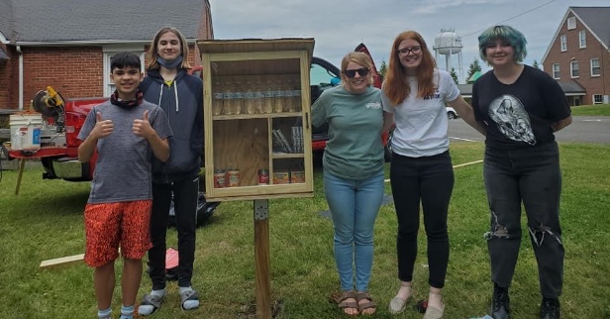

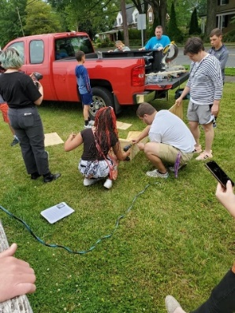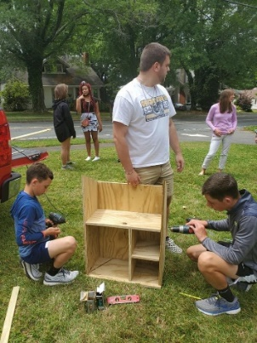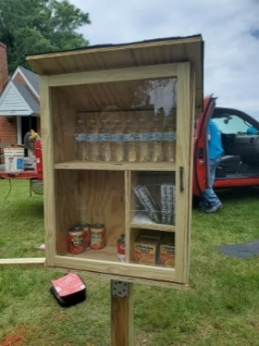

This past month our Juniors made Mother’s Day Bags for the residents at Priddy Manor and went hiking at Hanging Rock.
This month our Juniors are doing the following:
June 6 End of Year Pool Party

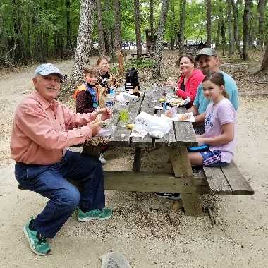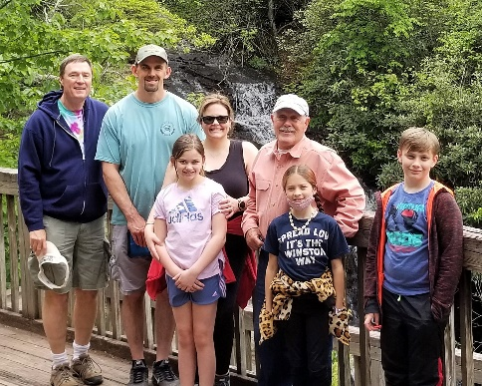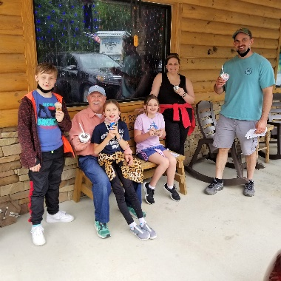

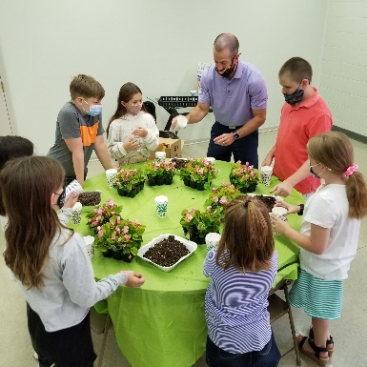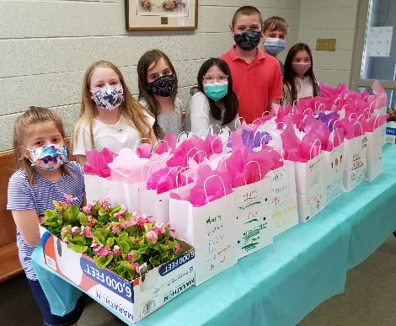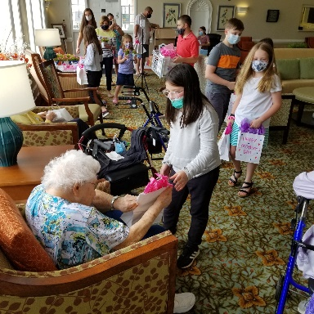
COLLEGE AGE NEWS
We had a great group attend our College Cookout at Pastor Doug’s home this past month. Besides some of our college students and those college age, it was also great having some of our graduating high school seniors there. Everyone enjoyed a great time of food, activities and sharing.

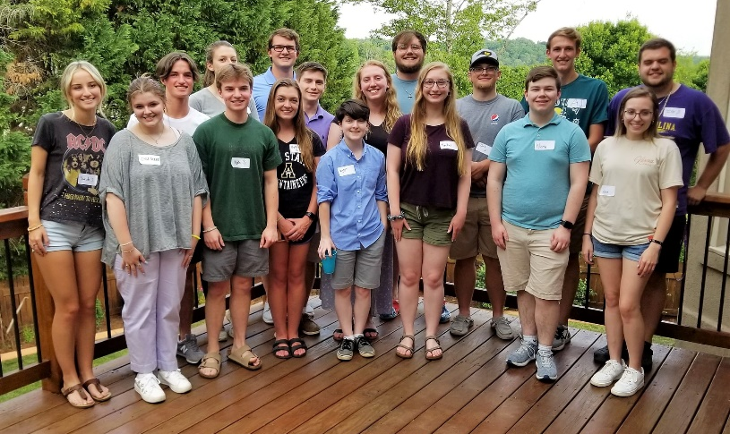

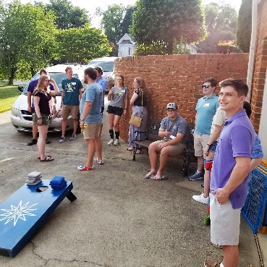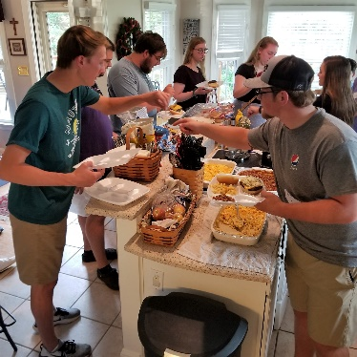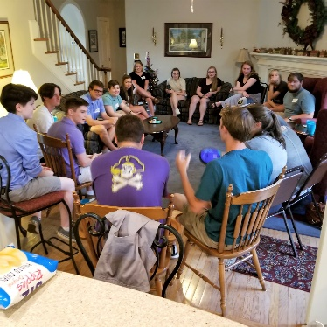
SOME PROVINCIAL NEWS
SUMMER CAMPS AT LAUREL RIDGE
Laurel Ridge, our Moravian Church Camp, plans to have in-person camps this summer. There will also be a virtual option for the camps for those who do not feel comfortable attending in-person.
2021 LAUREL RIDGE SUMMER CAMP SCHEDULE
Pre-Junior 1 (grades 1-2) June 26-28
Pre-Junior 2 (grades 1-2) July 31-August 2
Junior 1 (grades 3-5) June 13-19
Junior 2 (grades 3-5) August 2-8
Creative Arts Camp July 20-26
Middle High (grades 6-8) July 18-24
Senior High 1 (grades 9-12) July 11-17
Senior High 2 (grades 9-12) July 25-31
College Age Camp August 8-11

2021 MISSION CAMP SCHEDULE
Mission Camp 1 June 13-19 Mission Camp 3 July 4-10 Mission Camp 5 July 18-24
Mission Camp 2 June 27-July 3 Mission Camp 4 July 11-17 Mission Camp 6 August 1-7

IMPORTANT CAMP SCHOLARSHIP INFORMATION
Our church provides a camp scholarship for our young people who attend church camp at Laurel Ridge. Our church will pay one half of the camp fees for one camp for any of our members and family members who are active in our congregation. We are very thankful for the memorials made in memory of Omnie Grabs for camp scholarships that make these scholarships possible. When you register, please use the code “king2021” for the scholarship. If there is a financial need, please let us know because there may be other sources of funding for our church camps.

YOUTH AND YOUNG ADULT EVENT FOR THE NORTHERN, SOUTHERN
AND JAMACIAN PROVINCES
The Rt. Rev. Chris Giesler, the Director of Mission Engagement for the Board of World Mission (and Christ also grew up in our church family while his father, the Rev. John Giesler, was our pastor), would like to extend an invitation to our youth and young adults to join youth and young adults from the Jamaican, Northern and Southern Provinces of the Moravian Church to share a Zoom meeting. This event will be Saturday, June 12, from 3:00 p.m. until 6:00 p.m. The theme of this event is “Joshua Generation: Like, Follow, Share” and will deal with our biblical call to leadership and mission service. How can you find ways to engage in your community and around the world? How are you equipped? How will you do more than simply "like what you hear" in scripture, but instead, take it further by "following" and "sharing" these important lessons?
For more information about this event, please check out the following link:
https://www.moravian.org/mission/2021/05/03/join-in-on-a-joint-bwm-jamaican-province-online-youth-and-young-adult-event/

Financials

Offerings received through May 31: $149,143.45
Budget expenses through May 31: $139,445.59
2021 monthly contribution for shared Moravian Church Ministries: $4,597.17 per month has been paid through June.

CHURCH GIVING
We are very thankful for the thoughtfulness and generosity many of our members have shown to our church this past year when we have met and not met. We also realize this crisis may cause changes in people's circumstances, and we certainly understand. Whatever your situation may be, we hope you will prayerfully consider how you can support our church family. Besides those who bring their offerings to our worship services, we continue to receive our offerings through the following ways:
● You can mail your contribution to the church at King Moravian Church, 228 W. Dalton Road,
King, NC 27021.
● You can bring your contribution to the church office and deposit it in the slot in the security box
affixed to the wall outside the office door.
● You can give online through our church website www.kingmoravianchurch.org. Click on the
"Donate" button and follow the instructions to either use your PayPal login, if you have one, or use
a credit or debit card. Also, on our weekly email, King Konnections, you can click the link for our
website where it says “Donate to King Moravian” and follow the instructions.
● You can also donate online through the Moravian Ministries Foundation Giving Portal at the
following link (look King Moravian Church under "K"): https://mmfa.info/giving-portal/

June Birthdays
2- Carol Parker  2- Jonathan Allgood  3- Kim Grabs  4- Sue Gentry  4- Greg Taylor  4- Patti Durham  6- Kathy Anderson  7- Bill McElveen  7- Tom Tomchik  7- Shawne Grabs  10- Mark Smith  12- Ana Sapp  13- Paula Hall  15- Julia Simmons | 18- Gale Stone  20- Lewis Petree  20- Lindsey Smith  21- Dunivant Grabs  22- Avery Colburn  23- Andrea Seckman  24- Robert Simpson  25- Claire Colburn  26- Hillary Seckman  27- Diane Marion  27- Tim Parker  28- Jenn Harper  29- Maggie Monteith  30- Sue Donathan

PRESCHOOL PICTURES

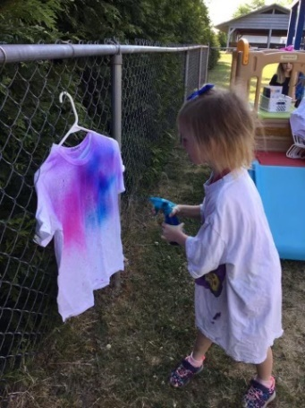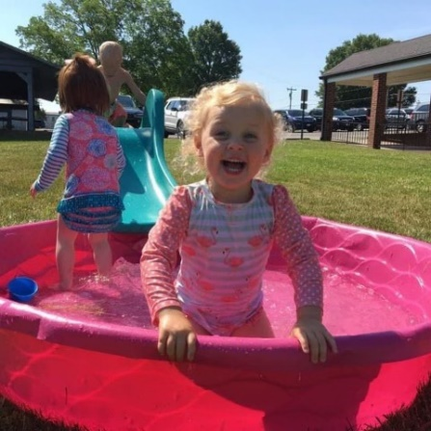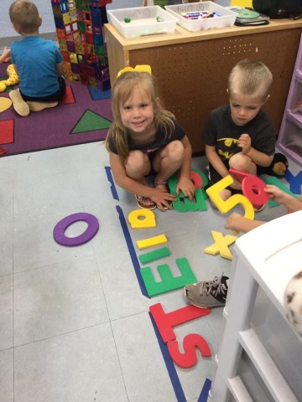

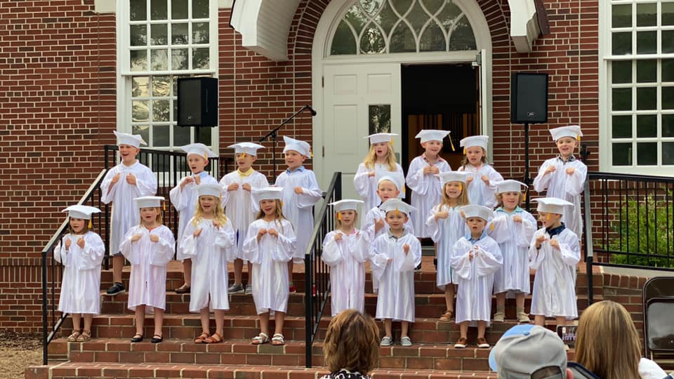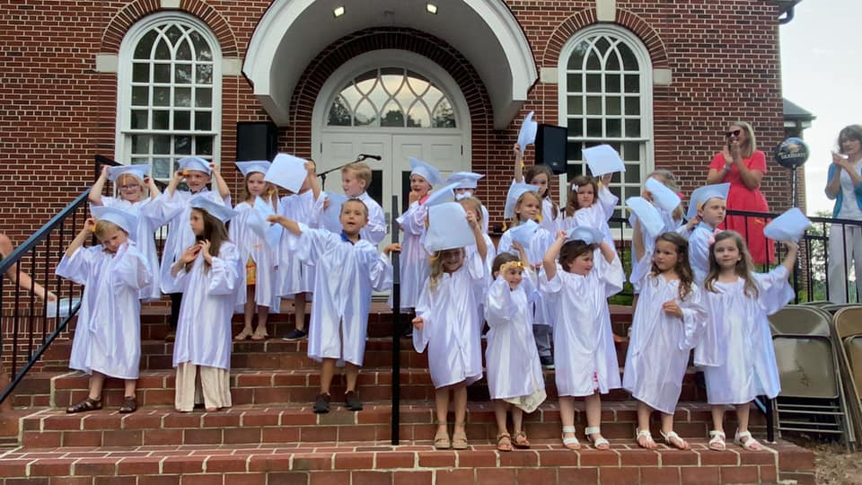

Pray Every Day June 2021
(A list of daily prayer concerns from our Board of World Mission)

- No one can serve two masters. Choose today whom you serve. Pray for our country and leaders.
- Incline your ear, and come to me. Pray for all suffering with Covid-19 virus and that all will use good judgment.
- May the Lord give you peace at all times. Pray for the Teshes in Kenya.
- He chose us in Christ before the foundation of the world. Pray for the Sutton’s with WEC.
- He has helped Israel in remembrance of His promise. Pray for Moravian outreach in Nepal.
- Sunday-Those who counsel peace have joy. Pray for those still suffering loss due to disasters.
- Let me hear of your steadfast love. Pray for those struggling to provide for their families.
- The kingdom of God is righteousness, peace and joy in the Holy Spirit. Pray for Dr. Benno and Teresa Marx.
- We must pay closer attention to what we have heard. Pray for Moravian ministers and for churches needing them to bring God’s word.
- For the love of God, we obey His command. Pray for Phil and Eunice Raiford.
- “But, who do you say that I am?” Pray that our government leaders will lead the country back to God.
- Pride goes before destruction. Pray for Brian and Heather Marx with MAF.
- Sunday-It is good to give thanks to the Lord. Pray for Annie B Missions (Star Mt)
- The Lord is good to those who wait for Him. Pray for Justin Rabbach (BWM).
- Devote yourselves to prayer. Pray for Moravians in Peru.
- By grace you have been saved. Pray for Jenna and Andrew Craver in Alaska.
- You have tasted that the Lord is good. Pray for the Hoffmans in HIV/AIDS Ministry.
- He will strengthen you and guard you from evil. Pray for Unity Women’s Desk.
- Woe to those who plan iniquity. Pray for the Harrisons with Greek University.
- Sunday-Seek the Lord while He may be found. Pray for the Sineaths in Campus Outreach.
- Come to me all of you who are weary and heavy ladened. Pray for Allan and DeeDee Iobst in France.
- The steadfast love of the Lord is everlasting. Pray for Steve and Ann Marx with MAF.
- I will lift my hands and worship you. Pray for Kevin and Charity in the Middle East.
- Let the Lord go with us, I pray. Pray for Charlie and Vickie Brent in Texas.
- His truth will be your shield and buckler. Pray for Alas de Socorro in Honduras.
- Blessed is he who comes in the name of the Lord. Pray for the food programs taking care of children without good nutrition.
- Sunday-. With God all things are possible. Pray for Armando Rusindo Foundation.
- They are mine and I will spare them. Pray for Adopt A Village in Tanzania
- He came to call sinners to repentance. Pray for the Thiessens in Mexico.
- Take hold of the eternal life, to which you have been called. Pray for Safiatu Braima and the church in Sierra Leone.

KMC Notes
June 2021

King Moravian Church
228 West Dalton Rd.
King, NC 27021

