January 2022

KMC Notes

Save the Dates …
Worship Services
Sunday, January 2 (First Sunday of 2022)
Walk Up Offering, Board Installation, Communion
Sunday, January 9 (First Sunday after the Epiphany)
Sunday, January 16 (Second Sunday after the Epiphany)
Sunday, January 23 (Third Sunday after the Epiphany)
Sunday, January 30 (Fourth Sunday after the Epiphany)

A NICE SURPRISE TO END THE YEAR AND SOME GREAT WORDS
TO BEGIN THE NEW YEAR

If you attended our last worship service for 2021 or you watched the service online, you know that at the end of the service I talked about the Moravian tradition of drawing watchwords for the new year. A watchword is a verse of Scripture. We have daily watchwords in our Moravian Daily Texts. We have weekly watchwords that you find in the Daily Texts which we also put in our church bulletins. We also draw a watchword for our congregation for the year. If you attended or watched service, you know what happened when I asked our Jennifer, our Church Organist, to draw a watchword for our church family for the new year. If you were not there or have not seen the service, something really neat happened.

For the service, my message was “The Christmas Gift of Jesus” and the key verse for the message was John 3:16. I talked about how the reason for Christmas is found in this one verse. In John 3:16 we see the greatest love as God loved us so much that He sent His Son. We see the greatest sacrifice as God sent His Son to die for us. We see the greatest choice, and the greatest choice you and I have in life is what you do with Jesus. When you choose him and receive Jesus into your life, it makes the greatest difference in you. And in John 3:16 we see the greatest destination which is eternal life with God in heaven.

At the end of my message, I talked about the watchwords. I had an offering plate filled with the watchwords which contained a lot of different verses. I turned to Jennifer, and I asked her to draw a watchword for our church for the new year. Jennifer reached into the offering plate and pulled out a watchword. I turned to those at the service to read the verse. I looked down at the verse, and I could not help but laugh, and laugh and then laugh some more. Of all the verses Jennifer could have picked in that offering plate, she pulled out . . . John 3:16!!!
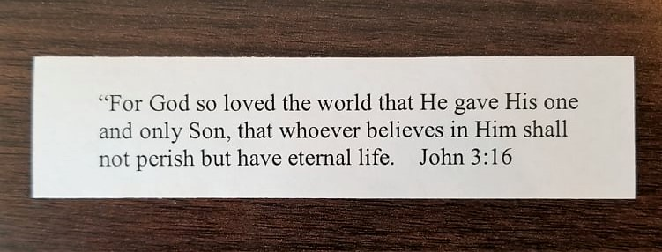

The Watchword Jennifer Pulled Out

The Watchword Jennifer Pulled Out

What a great watchword for our church family for 2022! John 3:16 is a verse that reminds us of God’s great love for us! It is a verse that reminds us of God’s great gift of Jesus! It is a verse that tells us the wonderful opportunity we have to believe in Jesus and experience the difference he makes in your life. And when you believe and live for Jesus, we have the greatest reward of a life forever with God in heaven. May 2022 be a year that we truly live out our watchword in thanks for all that God has done for us and for all that you and I can do for God!

In Christ’s love and service!
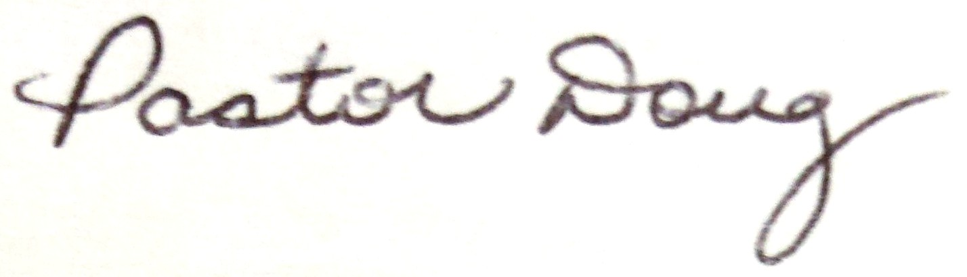

FIRST SUNDAY OF 2020 – SUNDAY, JANUARY 2
BOARD INSTALLATION, WALK UP OFFERING AND COMMUNION
Sunday, January 2, is the first Sunday of 2022. Our worship service will include the sharing of Holy Communion. Also, with it not only being the first Sunday of the new year, it will also be the first Sunday of the month. We will have our Walk Up Offering for King Outreach Ministry.
Our service will also include the installation of our Board of Elders and Board of Trustees for 2022. We welcome our new board members who were elected this past November. The newly elected members of our Board of Elders are Terri Lyda (who was reelected), Mark Johnson (who was reelected) and Barbara Sudol. Our newly elected members of our Board of Trustees are Darrell Goins (who was reelected), Paula Hall and Tim Huff. We will also install our newly elected youth representatives who are Gordon Grabs and Olivia Harper. We thank our outgoing board members who completed their terms this past year for their faithful service to our boards and to our church family. Our outgoing Elders are Holly Mathis and Zack Heath (youth representative). Our outgoing Trustees are Scott Cardwell, Dane Heath (who completed two terms), and Nate Hundley (youth representative).
Those serving on our 2022 church boards this year are:

BOARD OF ELDERS
Rachael Butts, Candice Covington, Doug Gordon, Gina Handy, Olivia Harper (youth representative), Paula Jennings, Mark Johnson, Terri Lyda,
Desty McEwan, Doug Rights and Cathy Saunders

BOARD OF TRUSTEES
Sue Donathan, Budge Gage, Darrell Goins, Gordon Grabs (youth representative), Paula Hall, C.W. Hill, Tim Huff, Jerry Saunders, Doug Spainhour
and Janie Young

FLOWER CALENDAR FOR 2022
Our 2022 flower calendar is located in the narthex. We appreciate those who have already signed up to provide flowers for our sanctuary. There are still some dates left for people to recognize family members or occasions in this special way. You can also call the church office to see about signing up for flowers.

CHURCH FAMILY NEWS

Congratulations to Eric and Briana Lyda upon the birth of their daughter, Lorelai Marie Lyda, on December 16 and congratulations to Lorelai’s grandparents, Ken and Terri Lyda. We also congratulate Mark and Heather Johnson upon the birth of their grandson, Silas Walter Kepley, on December 17, and to Gary and Maggie Monteith upon the birth of their great-granddaughter, Eloise Violet Edwards on December 26.

Congratulations to our December graduates! Kim Hall graduated from the University of North Carolina at Charlotte with a Master of Science in Nursing Education and Bailey Moran graduated from the University of North Carolina at Chapel Hill with a Bachelor of Science in Psychology and Exercise and Sport Science and a minor in Neuroscience. Bailey is the son of Tracy and Susan Moran.

Our congregation extends its Christian love and sympathy to Miranda and Nate Hundley upon the passing of their grandfather, Eley Hundley, on December 27.

In the hospital since our last newsletter have been Carolyn Byerly and Sarah Stevens.

SPECIAL WORDS OF THANKS

We thank everyone who attended our Candle Trimming on December 1. We had a great turnout as many people helped to get our candles ready for our Christmas Eve Lovefeast and Candle Services.

We thank everyone who gave to the Angel Tree Project who were April Bullin, Hope Campbell, Bonnie Crouch, Lynne Doby, Sue Donathan, Beth Donnelly, Hillary Douglas, Casey Elrod, Sue and Hughes Gentry, C.W. Hill, Heather Johnson, Fran Lucas, Terri Lyda, Holly Mathis, Fran Newsom, Michelle Newsome, Nan Pulliam, Jerry and Cathy Saunders, Brent and Andrea Seckman, Cynthia Sevier, Wayne and Sharron Simmons, Robert and Leah Simpson, Kristin Smith, Virginia Southern, Doug Spainhour and Diane Hoffman, Barbara Sudol, and Danny and Janie Young. We also thank Sue Gentry for all she did in organizing this project.
We thank Drake Flynt and his work crew, Rachael Butts, Desty McEwan, Brent and Andrea Seckman and all others who decorated our sanctuary, narthex and outside.

We thank those who lit our Advent Wreath this year for our worship services who were Hughes, Sue and Geoff Gentry; Dwayne, Tina, Sophie and Cooper Pratt; Danny and Janie Young; Kent, Jessica and Mallorie Wall; the Confirmation Class; Tyler, Jennifer, Tate, Brody and Bryce Shore; and Kathy and Shannon Anderson. We also thank Grant and Rachael Butts for lighting the Christ Candle for our Christmas Sunday. Special thanks to Ann Lawrence for providing our Advent Wreath.

We thank those who provided much of the wonderful music our church heard during Advent and Christmas. We thank our Director of Music, Drake Flynt, our organist, Jennifer Dunn, and our Adult Choir, for all they have done. Special thanks for their incredible service on Lessons and Carols on Sunday, December 12. If you have not see this year’s Lessons and Carols, you can find it at the following link:
https://youtu.be/LeYGA6Rul-0
We also thank Drake, Jennifer and our Choir for their special music for our Christmas Eve Services. We also thank our Morning Star soloists who were Hannah and Elizabeth Duncan and Breanna Sorrells. If you have not seen our Christmas Eve Service, you can see our 4:30 service at the following link:
https://youtu.be/8TQcOO4-nPU

We thank our dieners, ushers, hot chocolate makers, and coffee makers for the great job they did for our Lovefeast and Candle Services. Special thanks to Barbara Sudol for coordinating the services.

We thank the Gaylon and Carolyn Moran and their family for providing treat bags for some of our shut-in members. We also thank the members of the Moran family for their help with getting out our lovefeast kits with buns, coffee, candles and programs for our Christmas Eve Service.

We thank everyone who made donations in memory of and in honor of loved ones which provided the beautiful poinsettias for our church decorations. Those who were remembered and honored are the following:

Poinsettias and Luminaries Given in Memory of
Jim and Anna Anderson Our Parents
Joni, Chelsea and Maegan Boaz Dempsey and Margie Lilly
Mary Brown and Joanne Burrow Carrie Amanda Folk
Scott, Tracy, Cole and Mary Cardwell Walt Justis
Scott, Tracy, Cole, and Mary Cardwell John and Linda Williard
Ed and Ann Deal In Memory of loved ones
Jay and Sue Donathan C.J. and Bea Donathan
Jay and Sue Donathan Fred and Dora Watson
Hillary Douglas Garrell William Douglas
Hillary Douglas Carolyn Douglas Norman
Budge Gage Vonnie Gage
Hughes and Sue Gentry Mary Etta, Holton and Mary Ann Gentry
The Grabs Family Omnie Grabs Jr.
Bill and Margie Hall Our Family
Sally Hartgrove Dean Hartgrove
Sally Hartgrove Stanley Hartgrove
Sally Hartgrove Paul Meadows
Sally Hartgrove Rachel Joyce Meadows
C. W. Hill Mr. and Mrs. Bickett Hill
Allen Ray Horner Betty Horner
Mark and Heather Johnson Buck and Bettye Johnson
Anita Jones Mary and Gib Hammond
Dottie Jones Dr. and Mrs. J.R. Jones
Doug and Debra Jones Gene and Louise Chapman
Doug and Debra Jones Dr. and Mrs. J.R. Jones, Jr.
Tim, Lori and Taylor Justis Walter Justis
Joel and Martha Kiger Scott Kiger
Joel and Martha Kiger Joel Thomas Kiger Sr.
Don and Fran Lucas Woodrow and Havens Lucas
Don and Fran Lucas Grady and Agnes Stewart
Don and Fran Lucas Mary Ann Gentry
Ken and Terri Lyda Eloise Lyda
Ken and Terri Lyda Brian Moore
Ken and Terri Lyda Abrian Carroll
Fran Newsom Rev. and Mrs. Jimmie L. Newsom, Sr
Fran Newsom Joel Kiger
Fran Newsom T. W. Carmichael
Corkey and Carolyn Newsome Ross and Elise Newsome & Thelma Newsome
Corkey and Carolyn Newsome Edith and Ollie Ray Smith & Robert Smith
Corkey and Carolyn Newsome Cynthia Southern
Rev. and Mrs. Jim Pickett Claude and Leona Pickett
Rev. and Mrs. Jim Pickett Butch Williams
Gerald and Annette Pardue T.W. Carmichael
Bill and Nan Pulliam W. F. Pulliam Sr.
Bill and Nan Pulliam Wanda K. Lewis

Poinsettias and Luminaries Given in Honor of
Ken Alley Jerry and Karen Ranson
Ken Alley Ali and Sam Soots
Don and Reba Elliott Jackson and Davis Wood
Hughes and Sue Gentry Drake Flynt
The Grabs Family The 13 Grabs Grandchildren
Bill and Margie Hall Our Family
Mark and Heather Johnson Roger Cooke
Mark and Heather Johnson Jennifer Dunn
Mark and Heather Johnson Drake Flynt
Mark and Heather Johnson Jim and Jean Smith
Doug and Debra Jones Courtney, Boyd and Eleanor Neal
Doug and Debra Jones Geoff Jones
Doug and Debra Jones Dottie Jones
Dottie Jones Roger Cooke
Tim and Lori Justis Scarlett Smith
Tim and Lori Justis Mary Cardwell
Don and Desty McEwan Carolyn and Bill Byerly
Don and Desty McEwan Tina and Dwayne Pratt
Don and Desty McEwan Dane and Amy Heath
Tommy and Amy Reeves The Confirmation Class
Tommy and Amy Reeves The Youth Leaders
Doug and Kathy Rights Our Grandchildren: Nolan Key, Stella Key,
Damon and Dominic Vega
Lori Shore – Smith Tucker Smith
Virginia Southern Elsie Sampsell
Paul and Debbie Victor Our Six Grandchildren
Dan and Janie Young Matt Young and Reid Young

ANOTHER SPECIAL WORD OF THANKS
Dear King Moravian Church Family,
We would like to thank everyone for the wonderful cards, gifts and other expressions of kindness and generosity we have received for so many of you during this past Christmas season. You are a very special church family and we are very blessed to be here.
Doug and Kathy Rights

MIDDLE AND SENIOR HIGH YOUTH

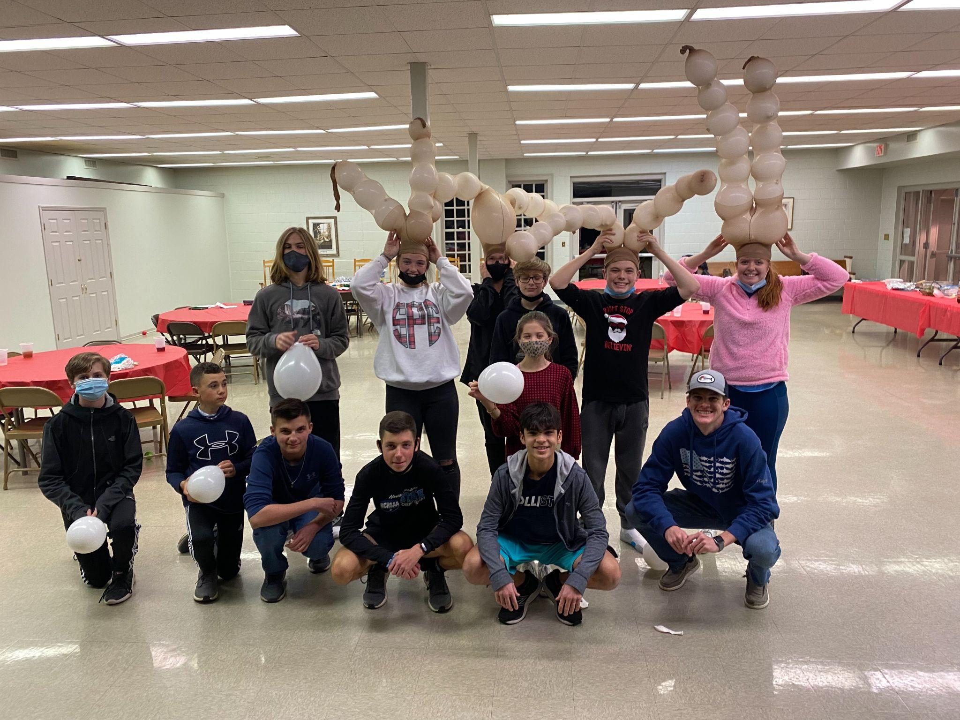

Merry Christmas from the middle and sr. high youth group!

Children’s Christmas Eve Lovefeast
2021
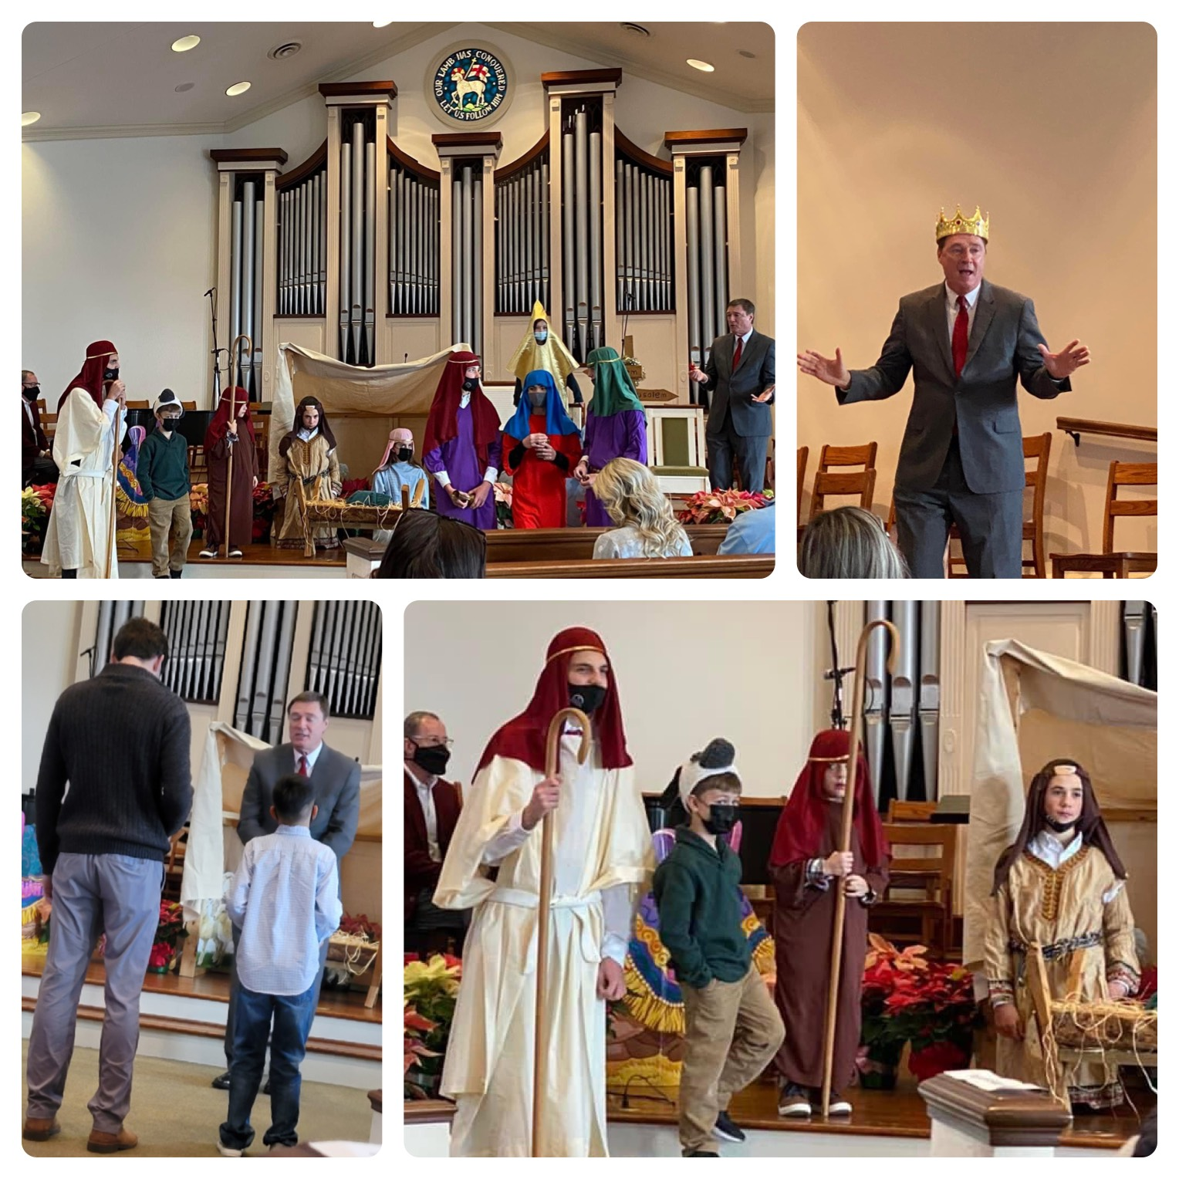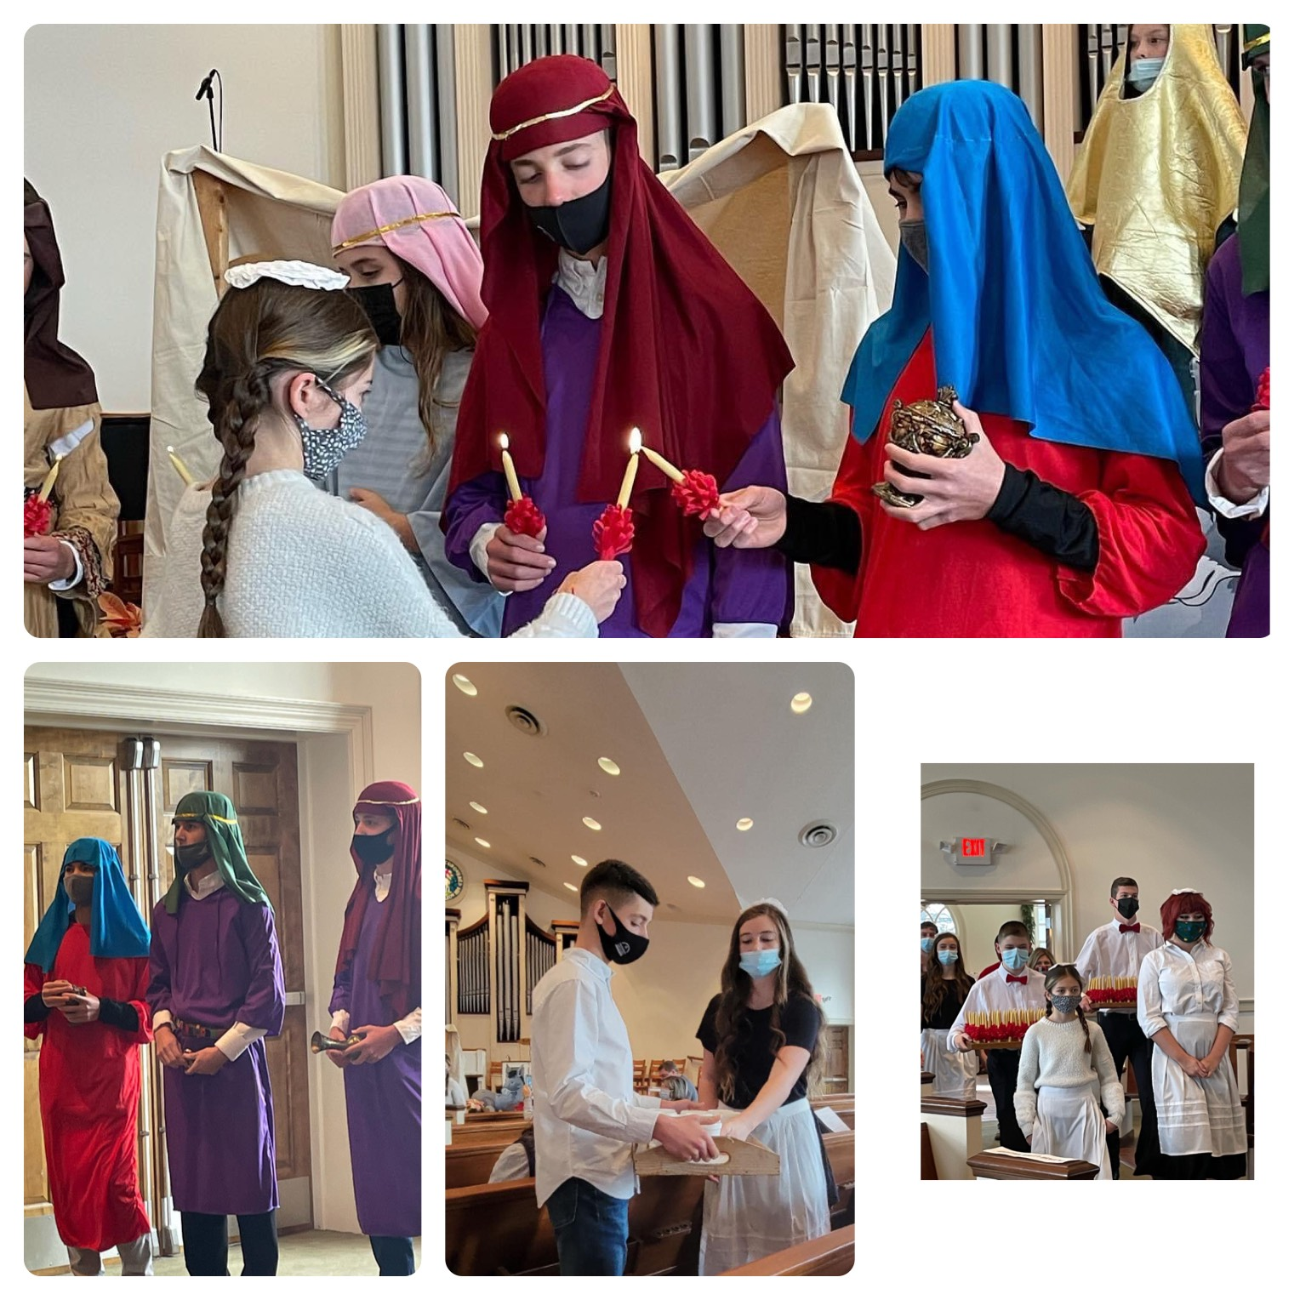
JUNIOR YOUTH
This past month our Juniors met to make Christmas cards and decorations for some of our members. They, along with some of our Senior Highs and Middle Highs, went Christmas caroling.

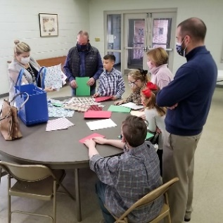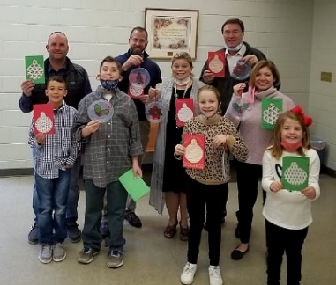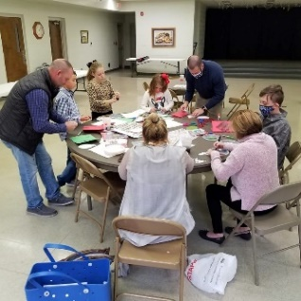

Making Cards and Decorations

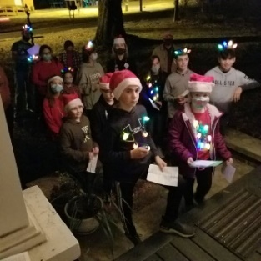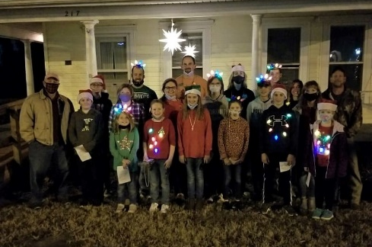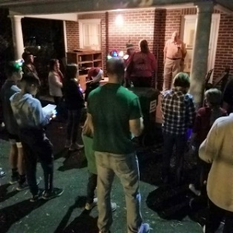

Christmas Caroling

At this time our Junior leaders are in the process of making plans for the upcoming months. Please keep an eye out for future programs and events.

Financials

Offerings received through December 27: $348,168.00
Budget expenses through December 27: $365,523.63
2021 monthly contribution for shared Moravian Church Ministries: $4,597.17 per month has been paid through December.

CHURCH GIVING
CHANGE IN ONLINE GIVING
For the past couple of years, we have had two ways people could give online either through PayPal or through our Moravian Ministries Foundation. Our Board of Trustees and Finance Committee have decided that we will no longer use PayPal for our online giving mainly because PayPal charges a fee for each transaction. The Moravian Ministries Foundation does not charge a fee. If you would like to make an online donation to our church, go to our church’s website, www.kingmoravianchurch.org, and click on the “Online Giving” link which will take you to our King Moravian Church Donation Form through the Moravian Ministries Foundation.
Besides our online giving, you can also give in the following ways:
● You can bring your contributions to our worship services.
● You can mail your contribution to the church at King Moravian Church, 228 W. Dalton Road,
King, NC 27021.
● You can bring your contribution to the church office and deposit it in the slot in the security box
affixed to the wall outside the office door.
We appreciate our many members and friends of our church family for your giving!

OFFERING ENVELOPES
In past years our church has ordered offering envelopes for all our members. Last year and this year we are checking with our members to see if you need envelopes or not. If you need offering envelopes, please call the church office or come by the office and get some.

CHURCH SCHEDULE FOR JANUARY

January 1 HAPPY NEW YEAR!!

January 2 Worship Service at 11:00 a.m.
Walk- up offering and Communion Sunday

January 4 King Moravian Preschool re-opens

January 7 - 8 Joint Board Retreat

January 9 Worship Service at 11:00 a.m.

January 16 Worship Service at 11:00 a.m.

January 19 Circle of Joy meets in the Fellowship Hall at 11:30 a.m.

January 23 Worship Service at 11:00 a.m.

January 30 Worship Service at 11:00 a.m.

January Birthdays
2- Anne Campbell Pace  3- Marion Smith  3- Ana Jennings  3- Brad Tuttle  6- George Sells  7- Ava Tilley  8- Sally Sipes  9- Gil Hammond  11- Sally Hartgrove  11- Angus Hammond  11- Lynn Emswiller  13- Terri Latham  14- Tracy Cardwell  15- Ed Sipes  15- Lori Easter  15- Joel Kiger  17- Carolyn Moran  18- Mac Powell | 18- Mary Strader  19- Tyler Patterson  19- Cory Easter  20- Ken Alley  20- Piper Mathis  21- Susan Moran  21- Maegan Boaz-Earley  22- Bonnie Crouch  22- Janie Young  24- Lynne Doby  24- Cecilea Harper  25- Ray Horner  26- Emily Monteith  26- Cooper Pratt  28- Bill Byerly  28- Robin Kincaid  30- Delaney Finn  31- Geoff Jones

BCM Lessons Announcement
The BCM is excited to announce that we have crafted a series of lesson plans featuring easy-to-use ZOOM plans PLUS at-home family faith options. Each lesson has a bible story, music, craft, and an opportunity to learn the bible scripture in sign language and Spanish.
The lessons begin at 9:00am and if you are unable to make the Zoom they will be recorded and you can participate at any time. If you are interested, please contact Rachael at rachsb94@gmail.com

Pray Every Day January 2022
(A list of daily prayer concerns from our Board of World Mission)

- You see, at just the right time, when we were still powerless, Christ died for the ungodly. Pray for Charlie and Vicki Brent in Texas.
- For all have sinned and fall short of the glory of God. Pray for Moravians in Peru.
- And hope does not disappoint us, because God has poured out his love into our hearts by the Holy Spirit whom he has given us. Pray for Moravians in Honduras.
- But where sin increased grace increased call the more. Pray for the Thiessens in Mexico.
- Therefore there is now no condemnation for those who are in Christ Jesus. Pray for the Unity Women’s Desk.
- What a wretched man I am! Who will rescue me from this body of death? Thanks be to God through Jesus Christ our Lord! Pray for the Harrisons with Greek InterVarsity.
- We ourselves, who have the first fruits of the Spirit, groan inwardly as we wait eagerly for our adoption as sons, the redemption of our bodies. Pray for the Board of World Mission.
- That if you confess with your mouth, ‘Jesus is Lord’ and believe in your hear that God raised him from the dead, you will be saved. Pray for Kevin and Charity in the Middle East.
- Everyone who calls on the name of the Lord will be saved. Pray for the Hoffmans in HIV/AIDS Ministry.
- Do not conform any longer to the patter of this world but be transformed by the renewing of your mind. Pray for PEC members, bishops and other church leaders.
- Love must be sincere. Hate what is evil; cling to what is good. Pray for Adopt A Village in Tanzania.
- Do not repay evil for evil. Be careful to do what is right in the eyes of everybody. Pray for disaster relief volunteers.
- Rejoice with those who rejoice; mourn with those who mourn. Pray for Phil and Eunice Raiford in Mexico.
- For I resolved to know nothing while I was with you except Jesus Christ and him crucified. Pray for the Clinica Evangelica Morava in Ahaus.
- For we are God’s fellow workers; you are God’s field, God’s building. Pray for the Rajpur Foster Child Project.
- Love is patient, love is kind. Pray for Moravians in Labrador.
- The sting of death is sin, and the power of sinis the law. But thanks be to God! He gives us the victory through our Lord Jesus Christ. Pray for seminarians and candidates for ordination.
- Always give yourselves full to the work of the Lord, because you know that your labor in the Lord is not in vain. Pray for firefighters and police officers.
- Be on your guard; stand firm in the faith; be men of courage; be strong. Do everything in love. Pray for short term mission teams.
- Therefore do not lose heart. Though outwardly we are wasting away, yet inwardly we are being renewed day by day. Pray for the medical personnel caring for Covid-19 patients.
- Therefore if anyone is in Christ; he is a new creation; the old has gone, the new has come! Pray for children’s and youth ministries.
- You know the grace of our Lord Jesus Christ, that though he was rich, yet for your sakes he became poor, so that you through his poverty might become rich. Pray for Brian and Heather Marx with Mission Aviation Fellowship.
- This service that you perform is not only supplying the needs of God’s people but is also overflowing in many expressions of thanks to God. Pray for Annie B Missions and Star Mountain.
- Let him who boasts boast in the Lord. Pray for Alan and DeeDee Iobst in France.
- My grace is sufficient for you, for my power is made perfect in weakness. Pray for Steve and Ann Marx with Mission Aviation Fellowship.
- I no longer live but Christ lives in me. Pray for the Sineaths in Campus Outreach.
- But do not use your freedom to indulge the sinful nature; rather, serve one another in love. Pray for the Teshes in Kenya and Ray of Hope.
- Let us not become weary in doing good. Pray for Moravians in Nicaragua.
- For we are God’s workmanship, created in him to do good works, which God prepared in advance for us to do. Pray for Moravians in Cuba and the Armando Rusindo Foundation.
- Be completely humble and gentle; be patient, bearing with one another in love. Pray for Safiatu Braima and Sierra Leone.
- Make every effort to keep the unity of the Spirit through the bond of peace. Pray for Michael and Brenda in Croatia.

KMC Notes
January 2022
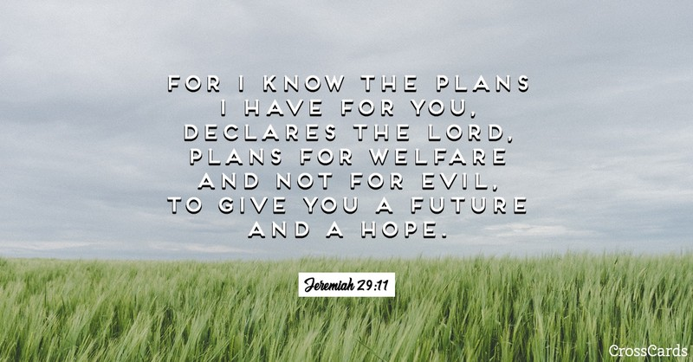

King Moravian Church
228 West Dalton Rd.
King, NC 27021

