October 2021

# **KMC Notes**



**Save the Dates …**

|  |
| --- |
| **We hope you will join us for our**  **Outdoor Worship Services**  **Sunday, October 3 (Anniversary Sunday)**  **Sunday, October 10 (Twentieth Sunday after Pentecost)**  **Sunday, October 17 (Twenty-First Sunday after Pentecost)**  **Sunday, October 24 (Twenty-Second Sunday after Pentecost)**  **Sunday, October 31 (All Saints Sunday)** |

**A GREAT SEASON AHEAD!**

I hope everyone had a great summer. It was nice seeing what many of our members and friends did these past few months. I enjoyed seeing pictures on Facebook and hearing about some of your travels and the things you did closer to home. Something I appreciated this summer was seeing a lot people at church on Sunday mornings whether in our sanctuary or out on our front lawn.

One thing I enjoyed this summer was getting together with some of our members on Tuesday afternoons for golf. From a young age I have enjoyed golf. My golf history began with playing putt putt at the course on Stratford Road in Winston-Salem. I then graduated to playing the Par 3 at Tanglewood Park which was just down the road from my home in Clemmons. I was fortunate that the manager of the course was my neighbor, and he gave me my start as I went from just putting to swinging the clubs.

When I came to King Moravian, my first few years I played golf once or twice a year. In a couple of other churches I’ve served, we made arrangements at a local course for a time when anyone from the church and friends could come together and play. I played and enjoyed those opportunities of golf and fellowship. One time one of guys I was playing was someone who was not a member of our church. He told me that if I hit a shot ten feet from the hole, he would come to our church the next Sunday. I hit one of the best shots I ever hit, which landed less than ten feet from the hole. He was at church the next Sunday and later joined our church.

I appreciated the Tuesday afternoons at the Pilot Knob Golf Course this summer. The manager at the course was very nice to give us a discounted rate. He was nice to give us a time when we could play. And Pilot Knob is a beautiful course with many great views of Pilot Mountain. I’ll have to admit that my golf game this summer was not good. I need to and want to get better. Yet what I appreciated more than the golf was the chance to be with some of our members and friends in a setting besides at church. I am thankful for the golf, but I am more thankful for the opportunity to get to know people better.

Summer is behind us. Our Tuesday golf outings will have to wait until next year. I hope the summer season was a good one for you. I hope this next season will be a great one for you. I think fall will be a great season for our church family. We begin the fall with our Anniversary Sunday. It continues with one of the great outreach ministries of our church with our Mission Blitz. We have a special event coming up with games and a chicken stew. Our Preschool resumes its Halloween Carnival which it had to postpone last year. Our youth groups are meeting. Our choir continues to share a lot of great music. Our Women’s Circles are meeting. In November we have our Church Council as we will be electing leaders for our church family. We will have our Thanksgiving Sunday. In December we will resume our Lessons and Carols which we were not able to have last year.



As I think about my golf game this past summer, I did not

play as well as I wanted. As I think about our church family,

we may not be able to do all we want to do as we continue to

deal with COVID. Yet even though everything is not the

same as it was two years ago, we still have our opportunities

to be together, to get to know people, and to build relation-

ships. It is my continued hope and prayer for all in our church

family that you and I grow in our relationship with the Lord

and that we grow in our relationships with each other. I hope

you will take advantage of all the opportunities this season to

be together.

In Christ’s love and service,

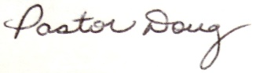

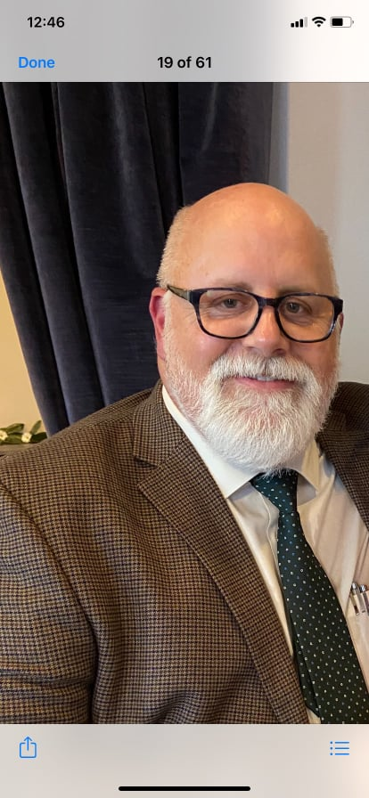

**WELCOME TO OUR NEWEST STAFF MEMBER**

Our ***Board of Trustees*** has hired our own ***Brent Seckman*** to serve as

the Facilities Manager for our church family. Brent’s duties will be to take

care of any maintenance which he is able to do, to contact outside help

such as plumbers, electricians, etc. when needed, assist with set up for

church events, and take care of the cleaning duties as we no longer contract

out our church cleaning. We are thankful for Brent’s willing to take this

position. He has already made a great difference.

If there are things he needs to be aware of, please let him know or call

the church office and we will pass on the information to him.

**SPECIAL SERVICES AND EVENTS IN OCTOBER**

**OUTDOOR SERVICES CONTINUE**

At this time we are continuing our Outdoor Services until the decision is made to return to the sanctuary. We will be on our front lawn. For those who would like to worship from their vehicles, we will have our FM transmitter.  For those who are not able to come or feel uncomfortable coming due to COVID, we will show our service live on our YouTube channel and our Facebook page.  You can also see a recording of the service on YouTube, Facebook and our church’s website.

For those coming to the services, we have the following precautions:

● We ask that you space yourself where you sit unless you are sitting with people you feel

comfortable with.

● A mask or face covering is optional.

● We ask that you don’t shake hands or give hugs at this time.

● Please don’t come if you’re sick.

● We are not offering any childcare at this time.

If you have any questions or need more information about any of these guidelines, you are more than welcome to contact any of our Task Force members who are ***Rachael Butts, Jennifer Dunn, Drake Flynt, Darrell Goins, Dane Heath, Ken Lyda, Holly Mathis, Desty McEwan, Barbara Sudol***and ***Doug Rights***.

**ANNIVERSARY SUNDAY – SUNDAY, OCTOBER 3**

Our church family will celebrate its 97th Anniversary on Sunday, October 3. We hope all who are able to come will be with us for this special day in the life of our church family. Our service will include sharing a lovefeast.

**WALK UP OFFERING – SUNDAY, OCTOBER 3**

**INCLUDES COAT AND SHOE DONATIONS FOR CHILDREN.**

On Sunday, October 3, we will have our Walk Up Offering for King Outreach Ministry. Also, on October 3 we are collecting new or gently used coats or shoes for children who need them at Poplar Spring Elementary.

**MISSION BLITZ**

**FRIDAY, OCTOBER 8 – SUNAY, OCTOBER 10**

Our Mission Blitz is Friday, October 8, to Sunday, October 10. If you would like to serve on one of the work teams, please turn in a Volunteer Form. We are also taking donations for anyone who would like to help cover the cost of our Mission Blitz. One way is to take an envelope off our Wall of Money and give the amount on the envelope. We are also collecting food for the homes we will serve. We are asking for the following items: bread, crackers, canned vegetables, beef stew, and peanut butter. If you would like to provide any of these items, please bring them to the church office or to church on Sunday, October 3.

**CHURCH ACTIVITY DAY AND CHICKEN STEW – SUNDAY, OCTOBER 17**

Our ***Board of Elders*** plans to have an afternoon where we got together for activities and a chicken stew on Sunday, October 17. The activities begin at 4:00 with kickball, volleyball and corn hole. The chicken stew begins at 6:00. We hope to have a great group come and enjoy a wonderful time of fellowship and food.

If you would like to help with some of the items needed for the chicken stew (crackers, whole milk, hot sauce, shredded cheese, drinks, desserts), please sign up at the following link:

https://docs.google.com/forms/d/e/1FAIpQLSd-pOxiz4-I3Kaz_9q4qphrrrUY1RSMvii1Z7RXphEjKeHnuA/viewform?vc=0&c=0&w=1&flr=0

**PRESCHOOL HALLOWEEN CARNIVAL**

**SUNDAY, OCTOBER 31**

Our Preschool is having its Halloween Carnival on Sunday, October 31, which will be in the afternoon from 2:00 p.m. until 5:00 p.m. For more information about the Carnival, please see the flyer with this newsletter.

**CONFIRMATION CLASS BEGINS THIS MONTH**

We are pleased to announce that we are having a ***Confirmation Class*** this year! There was an initial meeting this past month to see who was interested in attending. At this time those who have expressed interest in attending this year’s Confirmation Class are ***Jackson Goins, Elizabeth Grabbs, Ethan Harper, Chase Jackson, Piper Mathis, Cooper Pratt,*** and ***Charlie Reeves***. The class will begin meeting this month. If there are others who are interested, please contact ***Rachel*** or ***Pastor Doug***.

**AND COMING IN NOVEMBER**

**CHURCH COUNCIL – SUNDAY, NOVEMBER 14**

**NOMINEES FOR CHURCH BOARDS AND SYNOD DELEGATES**

We will have our annual Church Council meeting the second Sunday in November. We are looking for anyone interested in being a nominee for our ***Board of Elders*** and ***Board of Trustees***. Next year is another Provincial Synod, and we are looking for nominees for that as well. If you feel led be a nominee for either board or Synod, please contact anyone from our ***Nominating Committee*** who are ***Scott Cardwell, Darrell Goins, Dane Heath, Mark Johnson, Holly Mathis*** or ***Terri Lyda***.

**CHURCH FAMILY NEWS**

Our church family extends its Christian love and sympathy to ***the family and friends of Dick Stone***who passed away on September 4, ***the family and friends of Willie Thomas***who passed away on September 9, and to ***Claire Colburn and her family*** upon the passing of her mother, ***Carol Ann Hoffman***, on September 16.

Congratulations to ***Homer Dearmin*** who recently received the Silver Beaver Award for his word with the Boy Scouts. The Silver Beaver is the highest award an adult can receive in the Boy Scouts.

In the hospital since our last newsletter has been ***C.W. Hill***.

**SPECIAL WORDS OF THANKS**

We thank everyone who donated either money or supplies for our September Walk Up Offering that went to our Preschool.

We thank everyone who came out to Pilot Knob Golf Course these past few months to enjoy getting together for golf.

**SOME YOUTH FELLOWSHIP NEWS**

**SENIOR HIGHS AND MIDDLE HIGHS**

This past month our ***Senior Highs*** and ***Middle Highs*** met for Swimming and Fishing at the home of ***Brad and Maegan Earley***. Thank you, Chelsea Boaz, Brad and Maegan Earley, for opening up your home to the youth groups!!

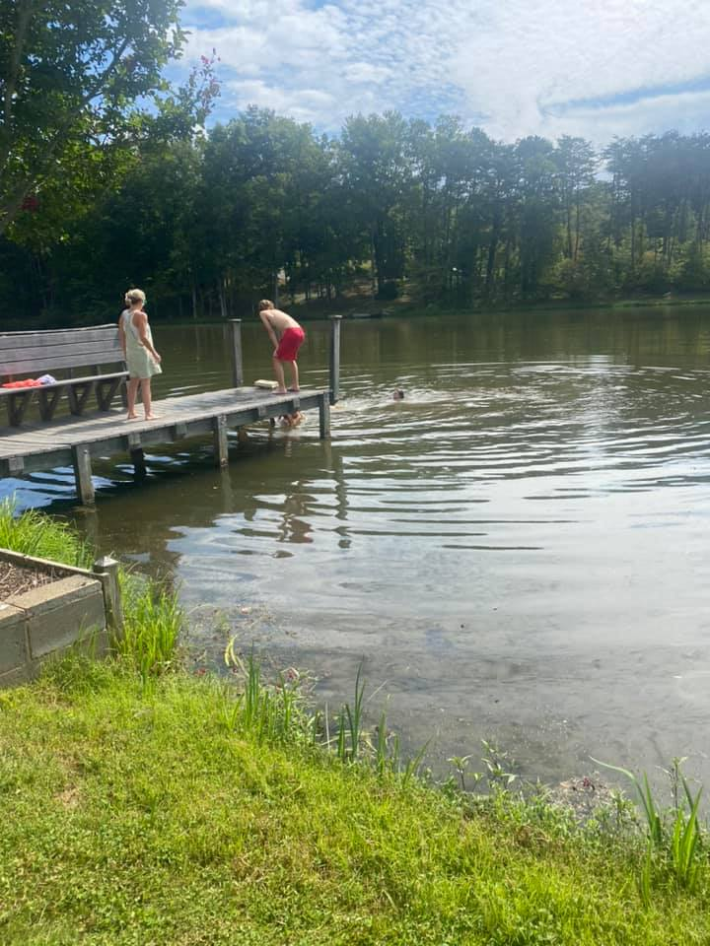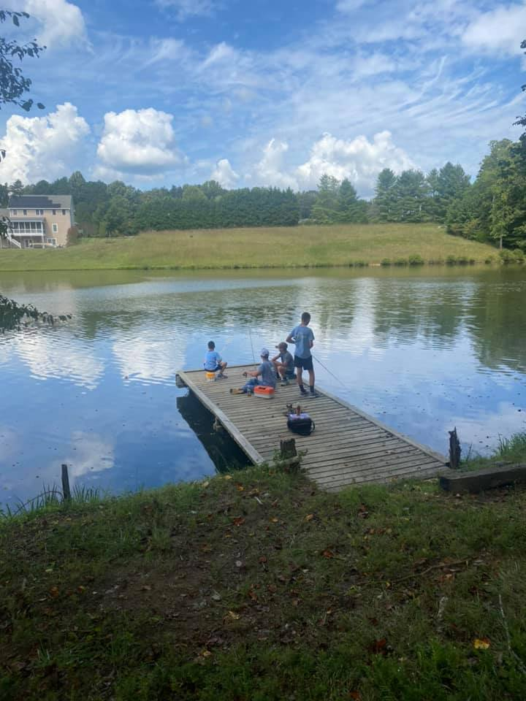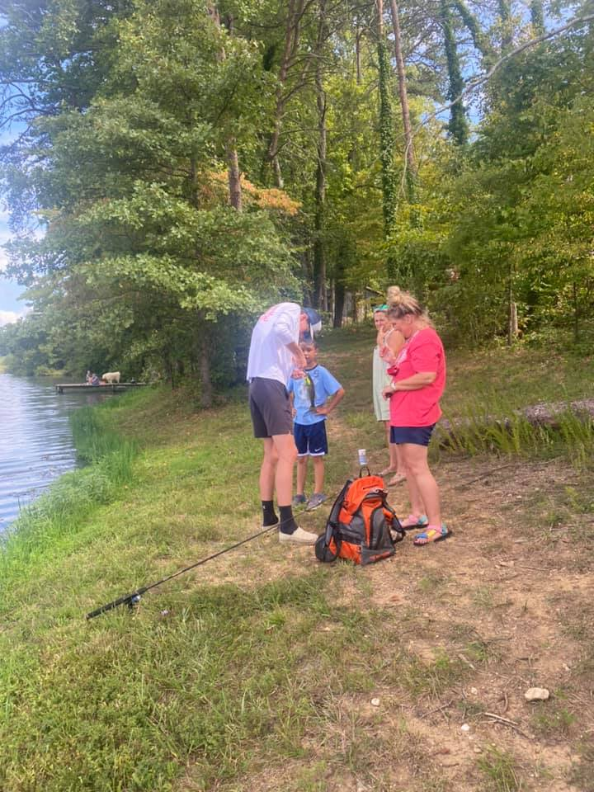

Swimming and Fishing at the Earley’s

Upcoming events for Middle and Sr. High youth:

October 9th- Mission Blitz projects

October 22nd- Spooky corn maze and lock-in

**JUNIORS**

Our ***Juniors*** began their year with a Pizza and Pool Party at the home of Perry and Renee Bowman on Sunday, September 12. They also had a Cookout and Planning Time on Sunday, September 26.

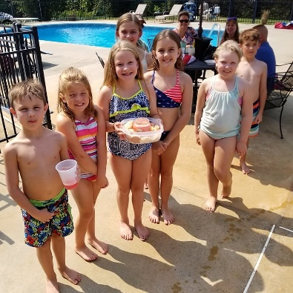 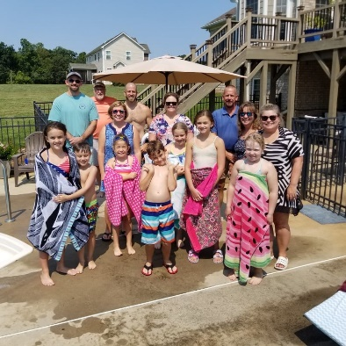 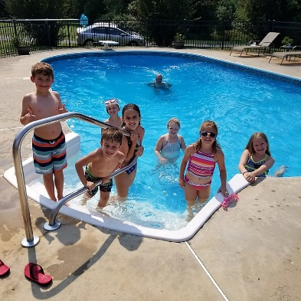

Pizza and Pool Party at the Bowman’s

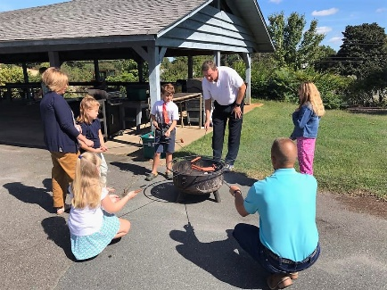 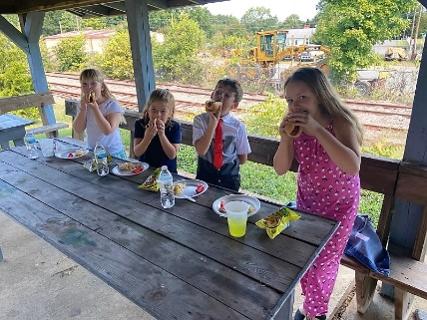 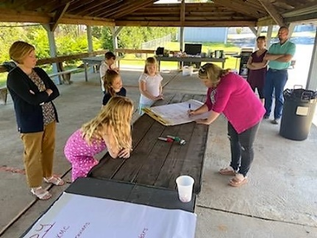

Cookout and Planning Time at the church

At this time we have the ideas for the programs and activities for our Juniors, but not the schedule. Please look for the dates and times of our Junior events.

|  |  |
| --- | --- |
| **Financials**    **Offerings received through September 20:** $**248,268.10**  **Budget expenses through September 20:** $**248,239.61**  2021 monthly contribution for shared Moravian Church Ministries: $**4,597.17** per month has been paid through July. |  |

**CHURCH GIVING**

We are very thankful for the thoughtfulness and generosity many of our members show to our church family despite continuing to deal with COVID. Here is a reminder of the ways you can give to our church family besides bringing it on Sunday mornings to our worship services.

● You can mail your contribution to the church at King Moravian Church, 228 W. Dalton Road,

King, NC 27021.  
 ● You can bring your contribution to the church office and deposit it in the slot in the security box

affixed to the wall outside the office door.  
 ● You can give online through our church website [www.kingmoravianchurch.org](http://www.kingmoravianchurch.org/). Click on the

"Donate" button and follow the instructions to either use your PayPal login, if you have one, or use

a credit or debit card. Also, on our weekly email, King Konnections, you can click the link for our

website where it says “Donate to King Moravian” and follow the instructions.  
 ● You can also donate online through the Moravian Ministries Foundation Giving Portal at the

following link (look King Moravian Church under "K"): [https://mmfa.info/giving-portal/](https://kingmoravianchurch.us7.list-manage.com/track/click?u=17ad779ff8e0b5a2d89ae22d3&id=5f279a0f80&e=d2acd2c841)

**If you give online, PayPal charges our church a fee for using their service.**

**The Moravian Ministries Foundation does not.**

**October Birthdays**

|  |  |
| --- | --- |
| 1 – Holly Mathis  1 – Eirik Oseguera  3 – Erin Allgood  3 – Zeb Mathis  3 – Dianna Hoffman  3 – Zollie Smith  4 – Bill Hall  4 – Corky Newsome  4 – Gary Monteith  4 – Ed Deal  5 – Annette Covington  5 – Louisa Covington  5 – Karen Gordon  8 – Bill Pulliam  9 – Bonnie Tomchick  9 – Gina Handy  10 – Susan Sullivan  10 – Carol Weatherbee  10 – Renee Smith  11 – Lee Easter  11 – Nate Sapp  11 – Russell Sapp  12 – Tommy Reeves  13 – Mark Johnson | 15 – Brody Shore  18 – Kim Hill  19 – Tina Pratt  19 – Scarlett Smith  20 – Liam Grubbs  21 – Harry Leonard  21 – Mallory Finn  21 – Naomi Stevens  22 – Danny Young  22 – Sara Russel  24 – Margie Hall  24 – Beth Easter  25 – Shannon Anderson  25 – Ann Deal  26 – Sam Hall  27 – Britt Patterson  27 – Darrel Goins  27 – John New  28 – Elke Card  28 – Kelly Nickell  29 – Paul Horner  31 – Liz Hensley  31 – Natalie Durham |

**CHURCH SCHEDULE FOR OCTOBER**

October 3 Outdoor Worship Service at 10:00 a.m.

Anniversary Sunday and Lovefeast

Walk Up Offering this includes Coat and Shoe Drive

October 6 Adult Choir – 7:00 p.m. (Every Wednesday Evening)

October 8  Mission Blitz Begins (Oct. 8th- Oct. 10th)

October 10 Outdoor Worship Service at 10:00 a.m.

October 12 Joint Board Meeting – 6:30 p.m.

October 17 Outdoor Worship Service at 10:00 a.m.

Church Chicken Stew and Games 4:00 p.m. – 7:00 p.m.

October 22 Senior Highs and Middle Highs – Spooky Corn Maze

(Meeting at the church at 7:00 p.m.)

October 24 Outdoor Worship Service at 10:00

October 31  Outdoor Worship Service at 10:00 a.m.

Preschool Halloween Carnival 2:00 p.m. – 5:00 p.m.

**PRESCHOOL PHOTOS**

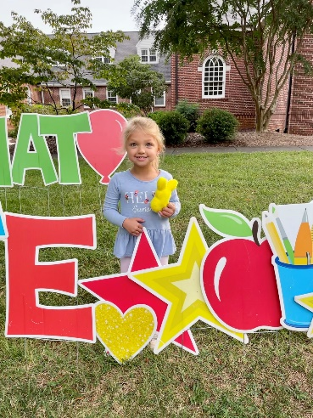 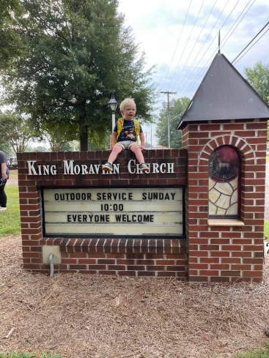 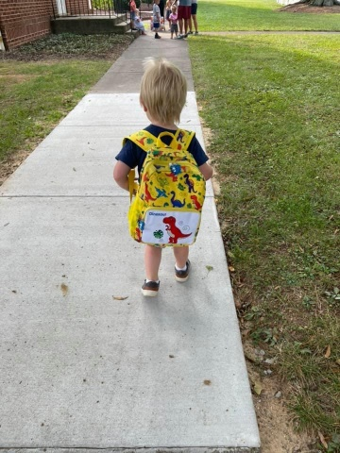

Stella Key ready to start her 3rd year Church member Liam Grubbs starting his 3rd year

at KMP! at KMP in the 2’s class!

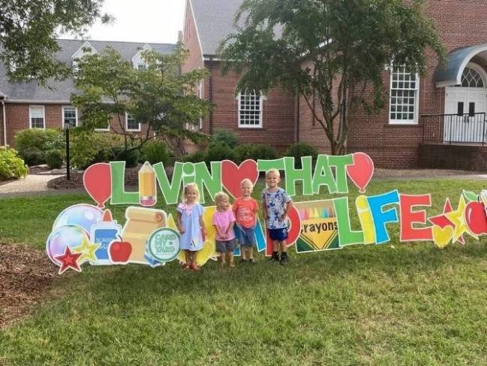 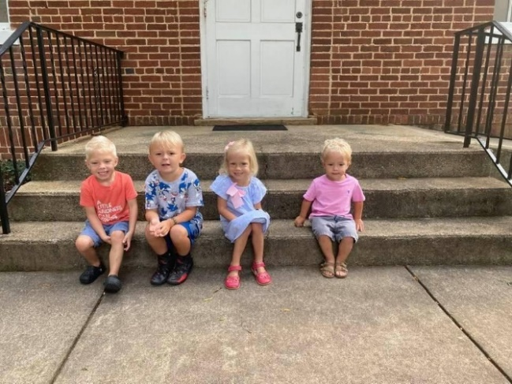

Through the years at KMP we’ve had many siblings, cousins, etc., but this little crew wins for the youngest. Cobey Martin started at KMP when he was 15 months. He is in our Pre-K 5’s this year! His three little

cousins are twins Maggie and Silas, and their brother Miles. This sweet crew is brought to KMP

by their grandparents Da & Mimi.





**Pray Every Day October 2021**

(A list of daily prayer concerns from our Board of World Mission)

1. I am making everything new! Write this down, for these words are trustworthy and true. Pray for disaster relief workers and Moravian Disaster Response.
2. This is the confidence we have in approaching God: that if we ask anything according to his will, he hears us. Pray for Michael and Brenda Brent in Croatia.
3. This is how we know what love is: Jesus Christ laid down his life for us. And we ought to lay down our lives for others. Pray for firefighters and police officers.
4. But if anyone obeys his word, God’s love is truly made complete in him. Pray for Charlie and Vicki Brent in Texas.
5. You ought to live holy and godly lives as you look forward to the day of God and speed its coming. Pray for the Moravian churches in Haiti.
6. Make every effort to add to your faith, goodness; and to goodness, knowledge; and to knowledge, self-control; and to self-control, perseverance, and to perseverance, godliness; and to godliness, brotherly kindness; and to brotherly kindness, love. Pray for the government leaders in our country.
7. If anyone serves, he should do it with the strength God provides, so that in all things God may be praised through Jesus Christ. Pray for short term mission teams.
8. For Christ died for sins once for all, the righteous for the unrighteous, to bring you to God. Pray for Safiatu Braima and Sierra Leonne.
9. But you are a chosen people, a royal priesthood, a holy nation, a people belonging to God, that you may declare the praises of him who called you out of darkness into his wonderful light. Pray seminarians and candidates for ordination.
10. Be patient, then brothers and sisters, until the Lord’s coming. Pray for the Moravians in Peru.
11. But the wisdom that comes from heaven is first of all pure; then peace-loving, considerate, submissive, full of mercy and good fruit, impartial and sincere. Pray for the Clinica Evangelica Morava in Ahaus.
12. Who is wise and understanding among you? Let him show it by his good life, by deeds done in the humility that comes from wisdom. Pray for Moravians in Cuba and the Armando Rusindo Foundation.
13. Everyone should be quick to listen, slow to speak and slow to become angry. Pray for PEC members, bishops, and other church leaders.
14. Consider it pure joy, my brothers, whenever you face trials of many kinds, because you know that the testing of your faith develops perseverance. Pray for Moravians in Honduras and Nicaragua.
15. And do not forget to do good and to share with others, for with such sacrifices God is pleased. Pray for the Raipur Foster Child Project.
16. Let us fix our eyes on Jesus, the author and perfecter of our faith who for the joy set before him endured the cross. Pray for the Teshes in Kenya and Ray of Hope.
17. Let us not give up meeting together, as some are in the habit of doing but let us encourage one another—and all the more as you see the day approaching. Pray for Phil and Eunice Raiford in Mexico.
18. Therefore he is able to save completely those who come to God through him, because he always lives to intercede for them. Pray for the Thiessens in Mexico.
19. For Christ did not enter a man-made sanctuary that was only a copy of the true one; he entered heaven itself, now to appear for us in God’s presence. Pray for Adopt-a-Village in Tanzania.
20. God is not unjust; he will not forget your work and the love you have shown him as you have helped his people and continue to help them. Pray for the Sineaths in Campus Outreach.
21. Therefore since we have a great high priest who has gone through the heavens, Jesus the Son of God, let us hold firmly to the faith we profess. Pray for the medical personnel caring for Covid-19 patients.
22. But encourage one another daily, as long as it is called Today, so that none of you may be hardened by sin’s deceitfulness. Pray for the Unity Women’s Desk.
23. He saved us not because of righteous things we have done, but because of his mercy. Pray for the Hoffmans in HIV/AIDS ministry.
24. For the grace of God that brings salvation has appeared to all people. Pray for Steve and Ann Marx with Mission Aviation Fellowship.
25. I have fought the good fight, I have finished the race, I have kept the faith. Pray for Kevin and Charity in the Middle East.
26. But you, keep your head in all situations, endure hardship, do the work of an evangelist, and discharge all the duties of your ministry. Pray for the Harrisons with Greek Intervarsity.
27. I thank God whom I serve, as my forefathers did, with a clear conscience, as night and day I constantly remember you in my prayers. Pray for Brian and Heather Marx with Mission Aviation Fellowship.
28. Until I come, devote yourself to the public reading of Scripture, to preaching and to teaching. Pray for Alan and DeeDee Iobst in France.
29. Now to the King, eternal, immortal, invisible, the only God, be honor and glory for ever and ever. Amen. Pray for Annie B Missions and Star Mountain.
30. Be joyful always; pray continually; give thanks in all circumstances, for this is God’s will for you in Christ Jesus. Pray for the Board of World Mission.
31. For what is our hope, our joy, or the crown in which we will glory in the presence of our Lord Jesus when he comes? Is it not you? Indeed, you are our glory and joy. Pray for Estamos Unidos Moravian Ministry.

KMC Notes

October 2021

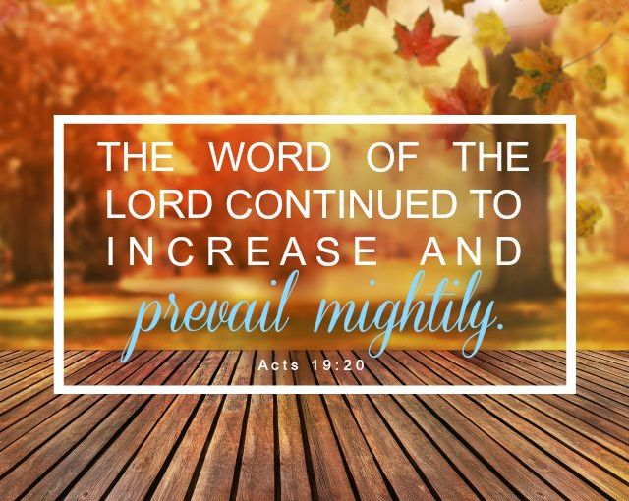

**King Moravian Church**

**228 West Dalton Rd.**

**King, NC 27021**