March 2020

KMC Notes
Save the Date….
March 4  7:00pm  Shepherding Committee meeting | March 7  5:00-8:00pm  KMP 31 Bingo Fundraiser in the fellowship hall | March 21  8:00am  Pine Needle Delivery Day  (Middle and Senior High youth helping spread pine needles; Help needed if you are available!) | March 28  8:00am-1:00pm  Church Clean Up Day  If you are able, please come out to help make sure our church is beautiful for our upcoming Easter season!

ARE YOU KEEPING UP?
It’s March! We’re two months into the new year! I first want to say, “Thank you!” to the many people who have been coming to church and who have been involved in our church family so far this year. I also want to say, “Thank you!” to the many members who attended our recent house meetings to talk about our church and share what you would like to see happen!
The second thing I’d like to share is if you haven’t been coming to church so far this year or haven’t been able to come that often due to sickness, work, being out of town, or other things that keep you from being here, I hope you’re keeping up with what’s going on at King Moravian.
There are many ways to keep up with what’s happening at our church. Reading the information in this newsletter is one way. Being on our email list and receiving the weekly King Konnections that our Administrative Assistant, Brooke Simpson, sends out. Also receiving emails when there are special services and events coming up or being informed when there are special needs in our church family.
A great way to keep up with what’s going on at King Moravian is listen to our Sunday services. This past month Kathy and I were out of town for a weekend. It was nice to get away. One of the nice things about getting home was I still had the opportunity to hear the Sunday service we missed. On the recording I heard some of the things going on in the church. I heard some wonderful and inspiring music. I heard a meaningful and challenging message.
On the Sundays you are not with us, I hope you’ll take the time to keep up. In regard to our Sunday service, we have a few ways you can hear it. We are more than willing to make a recording of our service on a CD and make it available for you. If you go on our church’s Facebook page, you can listen to the service there. If you are not on Facebook but you use the internet, you can find our services online in the following way:
1. Go to the website “spreaker.com” (“spreaker”, not “speaker”)
2. Click “Listen to Podcasts”
3. Go to the search bar and type “King Moravian Church”
4. Scroll down to:
King Moravian Church
Doug
Society and Culture
5. Click the date of the service you would like to listen to.
Now certainly the best way to keep up with our church is to be involved. Make the effort to be here as much as you can. We’re getting ready to start a special time in the church year with the season of Lent. It’s a great time to keep coming and a great time to get back to coming. A lot of great things are happening at King Moravian. We want you to know about them and experience them. And when you can’t be with us, please use what we offer you to keep up!
In Christ’s love and service,
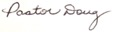

SPECIAL SERVICES AND EVENTS IN MARCH
THE SEASON OF LENT HAS BEGUN
We began the season of Lent on Wednesday, February 26, with our Ash Wednesday Service. Lent is the period of forty days from Ash Wednesday until Easter (not counting Sundays). It is a time when we prepare our hearts for the coming celebration of Easter. We hope you will let our worship services and other special services during this time be ways for you to spiritually prepare for the great celebration of Jesus’ resurrection and the difference it makes in our lives.
FIRST SUNDAY IN LENT
SUNDAY, MARCH 1
On Sunday, March 1, we will observe the first Sunday of Lent. Part of our service will include the celebration of Holy Communion. At this service, Pastor Doug will begin a series of Lenten messages.
DAY OF PRAYER SERVICES
During the season of Lent our Moravian congregations in the Winston-Salem area will have their Day of Prayer Services. These services take place on Wednesdays at 11:00 a.m. at different churches and there is also a service on Sunday afternoon, March 1, at 2:00 p.m. which includes a lovefeast. Everyone is invited to attend these services. The Day of Prayer schedule is:
Sunday, March 1 at Christ Moravian
Speaker: Rev. Richard Spaugh
Service includes a Lovefeast

Wednesday, March 4 at Trinity Moravian
Speaker: Rev. Chris Thore
Free luncheon following the service

Wednesday, March 11 at Ardmore Moravian
Speaker: Rev. Daniel Dockery

Wednesday, March 18 at Calvary Moravian
Speaker: Rev. Adam Goodrich

Wednesday, March 25 at Fairview Moravian
Speaker: Rev. Zachery Dease
Service includes Communion

Wednesday, March 4 at Konnoak Hills Moravian
Speaker: Rt. Rev. Carol Foltz
Service includes a Lovefeast
PINE NEEDLE SALE
Our Men’s Fellowship is pre-selling pine needles now until delivery on Saturday, March 21. The pine needles will be available on March 21 from 8:00 a.m. until 12:00 noon. The cost is $5.00 per bale if picked up and $7.00 per bale delivered and spread. There is a $15 fee for delivery. Order slips are available at the church or you can call the church office to place your order at (336) 283-5322 or call Robert Simpson at (336) 971-0500.
CHURCH FAMILY NEWS
Our church family extends its Christian love and sympathy to Roger Cooke and his family upon the passing of his sister, Mildred Tilley, on February 7.
In the hospital since our last newsletter have been Walt Harper, Ray Horner, and Victoria Smith.
WELCOME TO OUR NEWEST MEMBERS
On Sunday, February 2, we welcomed the following to our church family:
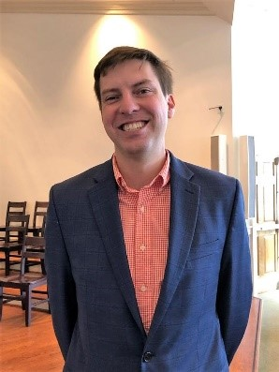
Grant Butts
Grant transfers his membership from Poplar Springs Church of Christ in King. He is married to Rachael Butts, our Director of Christian Education. Grant works for Williams Printing in Rural Hall. Some of the ways Grant wants to service our church is help with church maintenance (both indoor and outdoor), help with local mission projects, and help with youth events. His shepherd is his wife, Rachael Butts.

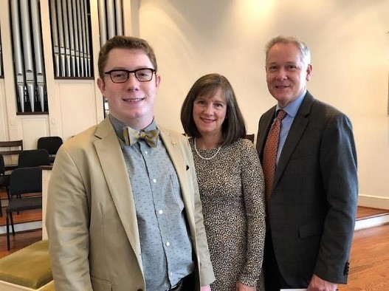
Chris and April Bullin
Jacob Bullin
Chris and April Bullin and their son, Jacob, transfer their memberships from Mizpah Moravian Church in Rural Hall. Chris is the Manager at Banana Republic at Hanes Mall in Winston-Salem. April is a Program Assistant for the Liberal Arts Studies, MA at Wake Forest University. Jacob is a student at Forsyth Tech Community College and works at Old Navy in Hanes Mall. Chris would like to help with our outdoor projects and serve as a greeter and diener. April would like to help with meals at the time of a funeral, serve as a greeter, and has already joined our Adult Choir. Jacob would like to help with our audio equipment, serve as a diener and help trim our Christmas candles. Their shepherds are Doug and Kathy Rights.
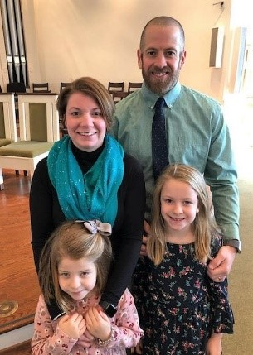
Jay and Emily Duncan
Jay and Emily transfer their memberships from Trinity United Methodist Church in King. They have two children, Hannah and Elizabeth. Jay is a teacher at Poplar Springs Elementary School. Emily is a librarian at Poplar Spring Elementary School. Some of the ways Jay would like to serve include as an usher, help with local mission projects, and help in our youth ministry with our Junior youth. Emily would like to sing in the choir, play handbells, and also help with our youth ministry with our Junior youth. Their shepherds are Chris and Candace Covington.

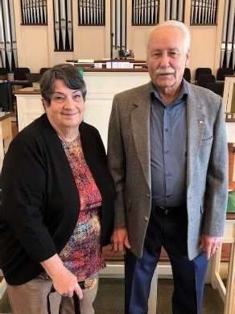
John and Jane Elolf
John and Jane transfer their memberships from Trinity Moravian Church in Winston-Salem. John is retired from Envision Printing in King. Jane is retired from Tally’s Florist in King. John would like to help with our church maintenance (both indoor and outdoor projects), help with the Brunswick Stew, and trim our Christmas trim candles. Jane would like to help with our Church Bazaar and also help trim our Christmas candles. John’s shepherd is Randall Patterson, and Jane’s shepherd is Sarah Stevens.
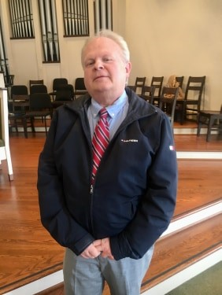
C.W. Hill
C.W. transfers his membership from Mt. Olive Baptist Church in King. He works as an auditor for the North Carolina Department of Commerce. C.W. would like to serve on our Board of Trustees and our Finance Committee, as usher, as a greeter, and as a Pastor’s Prayer Partner. His shepherd is Hughes Gentry.
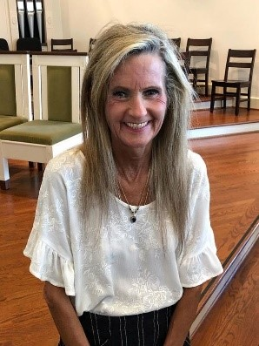
Terri Lathan
Terri transfers her membership from Victory Baptist Church in King. She had worked for Home Depot and now cares for her husband, John. Terri would like to help with Vacation Bible School, help get our church ready for Sunday mornings, and help trim our Christmas candles. Her shepherd is Fran Newsom.

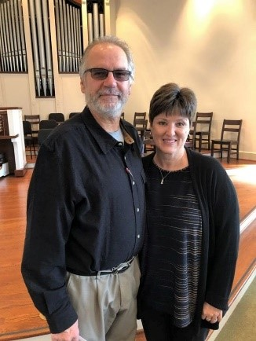
Zollie and Renee Smith
Zollie and Renee transfer their membership from Trinity United Methodist Church in King. Zollie works for Pilot Flooring, and Renee works at the Senior Center in King and part time at Tally’s Florist. Zollie would like to serve in our missions and help with our youth. Renee would also like to serve in our missions and help with our youth. Their shepherd is Jim Anderson.
SPECIAL WORDS OF THANKS
We thank everyone who came to our Safe Sanctuary Training on February 5. If you are working with our youth children or would like to work with them but you have not received the training, please contact Rachael Butts.
We thank Nola Knouse, Director of the Moravian Music Foundation and clergy member of our Provincial Elders Conference, for planning our worship service and for bringing the message on February 16 while Pastor Doug was away. We also thank Desty McEwan for her help with the service and Rachael Butts for sharing the Children’s Message.
We thank those who helped with our goal setting this past month. We thank everyone who attended the meetings. Special thanks to those who were willing to host the meetings who included Jay and Sue Donathan, David and Patti Durham, Hughes and Sue Gentry, Omnie and Susie Grabbs, Sonny and Anna Grubbs, Don and Desty McEwan, Don and Fran Lucas, Brent and Andrea Seckman, George and Andi Sells, and Doug Spainhour and Diane Hoffman. Special thanks also to our board members who let the services who included Jennifer Burge-Carter, Rachael Butts, Candace Covington, Darrell Goins, Doug Gordon, Dane Heath, Zach Heath, Mark Johnson, Holly Mathis, Desty McEwan, Shiela Patterson, Doug Spainhour, and Janie Young.
We thank everyone who turned in their Time and Talent Sheet. We appreciate people sharing how they want to spend their time, their talents and their treasure for God and for the ministry of our church family. We look forward to the many ways people’s time, talents and treasure will be used in the life of our church.
OTHER SPECIAL WORDS OF THANKS
Thank you so very much for your prayers and comfort you provided for me and my brother, Harry Nieberle, in the loss of our brother, Arthur Nieberle. Also, thank you for the very meaningful Christmas cards sent to me. They were a big part of my Christmas.
Elke Card
YOUTH FELLOWSHIP NEWS
OUR JUNIOR YOUTH FELLOWSHIP
This past month our Juniors learned about Pastor Doug, made Valentine cards for our shut-ins, and learned about John the Baptist.
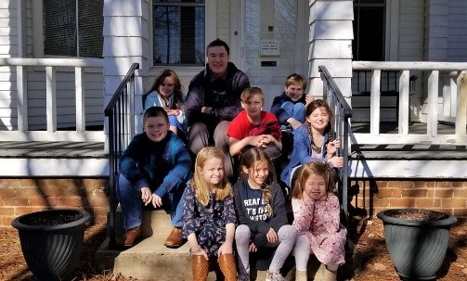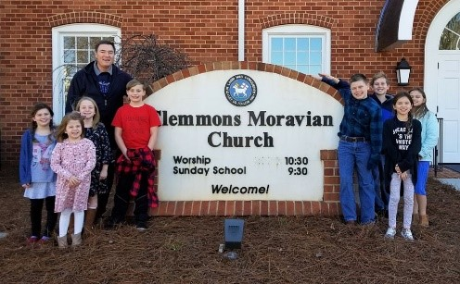
Juniors learn more about Pastor Doug
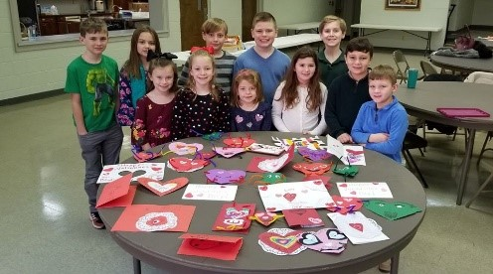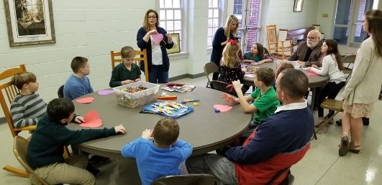
Juniors making Valentine Cards for Shut-Ins
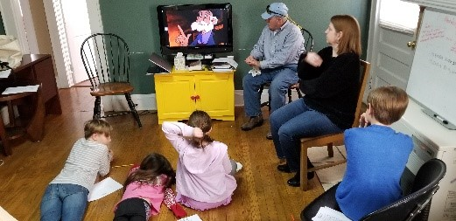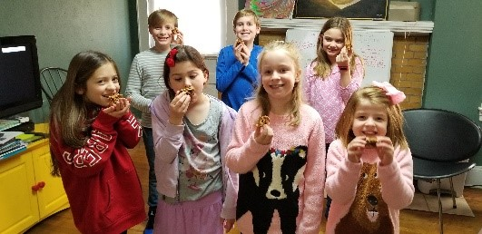
Juniors learning about John the Baptist
This month our Juniors are doing the following:
March 8 Going to SciWorks
March 22 Learning about Easter
2020 LAUREL RIDGE SUMMER CAMP SCHEDULE
Pre-Junior 1 (grades 1-2) June 12-14
Pre-Junior 2 (grades 1-2) July 31-August 2
Junior 1 (grades 3-5) June 28-July 4
Junior 2 (grades 3-5) August 2-8
Creative Arts Camp July 5-11
Middle High (grades 6-8) July 19-25
Senior High (grades 9-12) July 12-18
Back to School for College Age August 9-11
2020 MISSION CAMP SCHEDULE
Mission Camp 1 June 14-20
Mission Camp 2 June 21-27
Mission Camp 3 June 28-July 4
Mission Camp 4 August 2-8
For more information about any of these camps, please check the Laurel Ridge website which is www.laurelridge.org.
IMPORTANT CAMP SCHOLARSHIP INFORMATION
Our church provides a camp scholarship for our young people who attend church camp at Laurel Ridge. Our church will pay one half of the camp fees for one camp for any of our members and family members who are active in our congregation. When you register, please use the code “king2020” for the scholarship. If there is a financial need, please let us know because there may be other sources of funding for our church camps.

BILL HALL RECEIVES THE JAMES V. SALZWEDEL AWARD FOR
EXCELLENCE IN CHURCH MUSIC
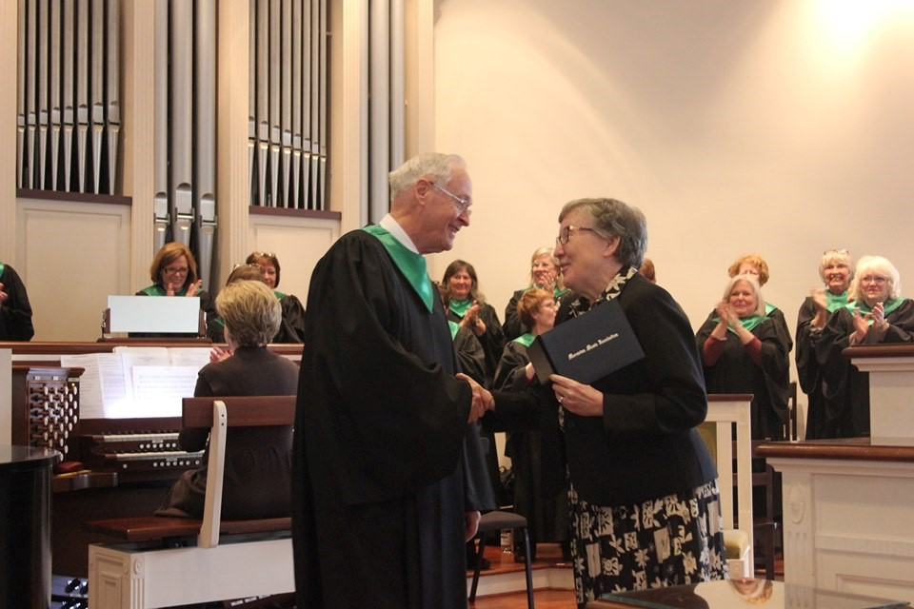
On Sunday, February 16, during our worship service our own Bill Hall received the James V. Salzwedel Award for Excellence in Church Music which is given by the Moravian Music Foundation. The Rev. Dr. Nola Knouse, the Director of the Moravian Music Foundation, was with us that Sunday, and she presented the award to Bill. Bill is very deserving of this award through the number of years he has served as a choral director in several churches, his involvement in church choirs, and his love for the Lord which is shown through his music. Here is what was said about Bill in the presentation:
MORAVIAN MUSIC FOUNDATION
William A. (Bill) Hall
You have been a choral director for 39 years, serving Rural Hall Methodist, Rural Hall Church of Christ, Central Terrace Methodist, Madison Methodist, Bethania, Mayodan, and Fairview Moravian, and the Great Sabbath Chorus. You have sung, including serving as soloist, with the Moramus Chorale, Great Sabbath Chorus, Calvary Moravian, King Moravian, and Maple Springs United Methodist Churches. You have served as substitute director and bass soloist at King for many years, and you also served on the Board of Trustees. You continue to be a wise and caring leader, possessed of a delightful dry humor. You show a great commitment to Moravian music and a passion for singing. Yet your greatest drive is serving your Savior, Jesus Christ, with the gifts you have been given. You are a model director, soloist, and choral singer, always giving your best to the glory of God.
For your dedicated service; your joyful sharing of the gift of music in and beyond worship; and your contribution to the preservation, sharing, and celebration of Moravian musical culture; the Board of Trustees of the Moravian Music Foundation takes great delight in presenting to you the

JAMES V. SALZWEDEL AWARD FOR EXCELLENCE IN CHURCH MUSIC
Winston-Salem, North Carolina, February 16, 2020
Bill! We are very proud of you and very blessed to have you as part of our Choir and our church family!
Financials

Offerings received through February 23rd: $55,078
Budget expenses through February 28th: $55,192
Monthly contribution for shared Moravian Church Ministries: $4,772.50 per month has been paid through February.

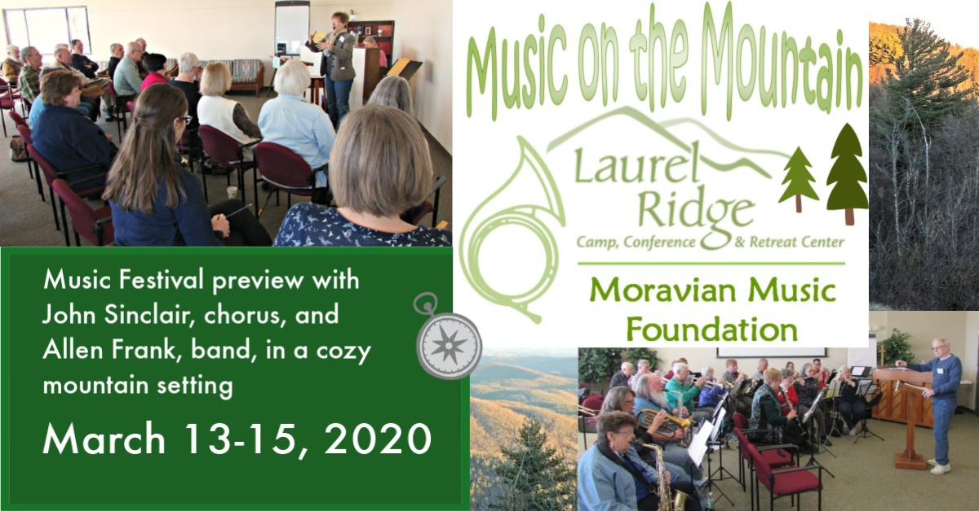

**If you are an up and coming college student and plan on applying for the Brandon or Booe scholarships, you must have your application turned into the church office by May 1st! This scholarship is available to church members, their children, and grandchildren.Please contact the church office for more information or to get an application.
336-283-5322 or office@kingmoravianchurch.org**

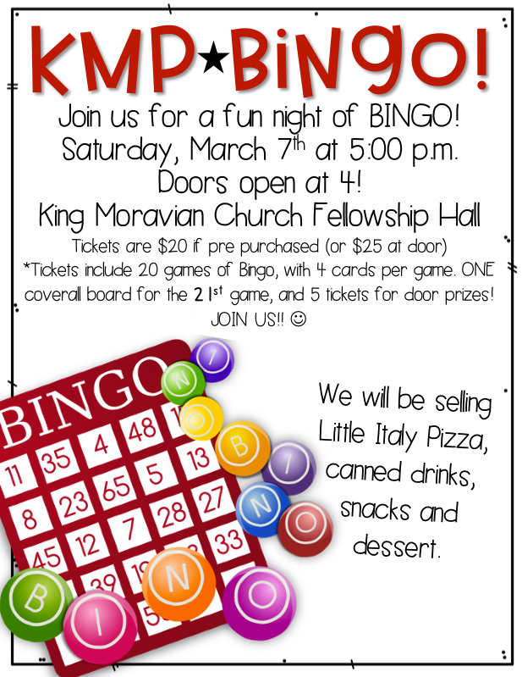

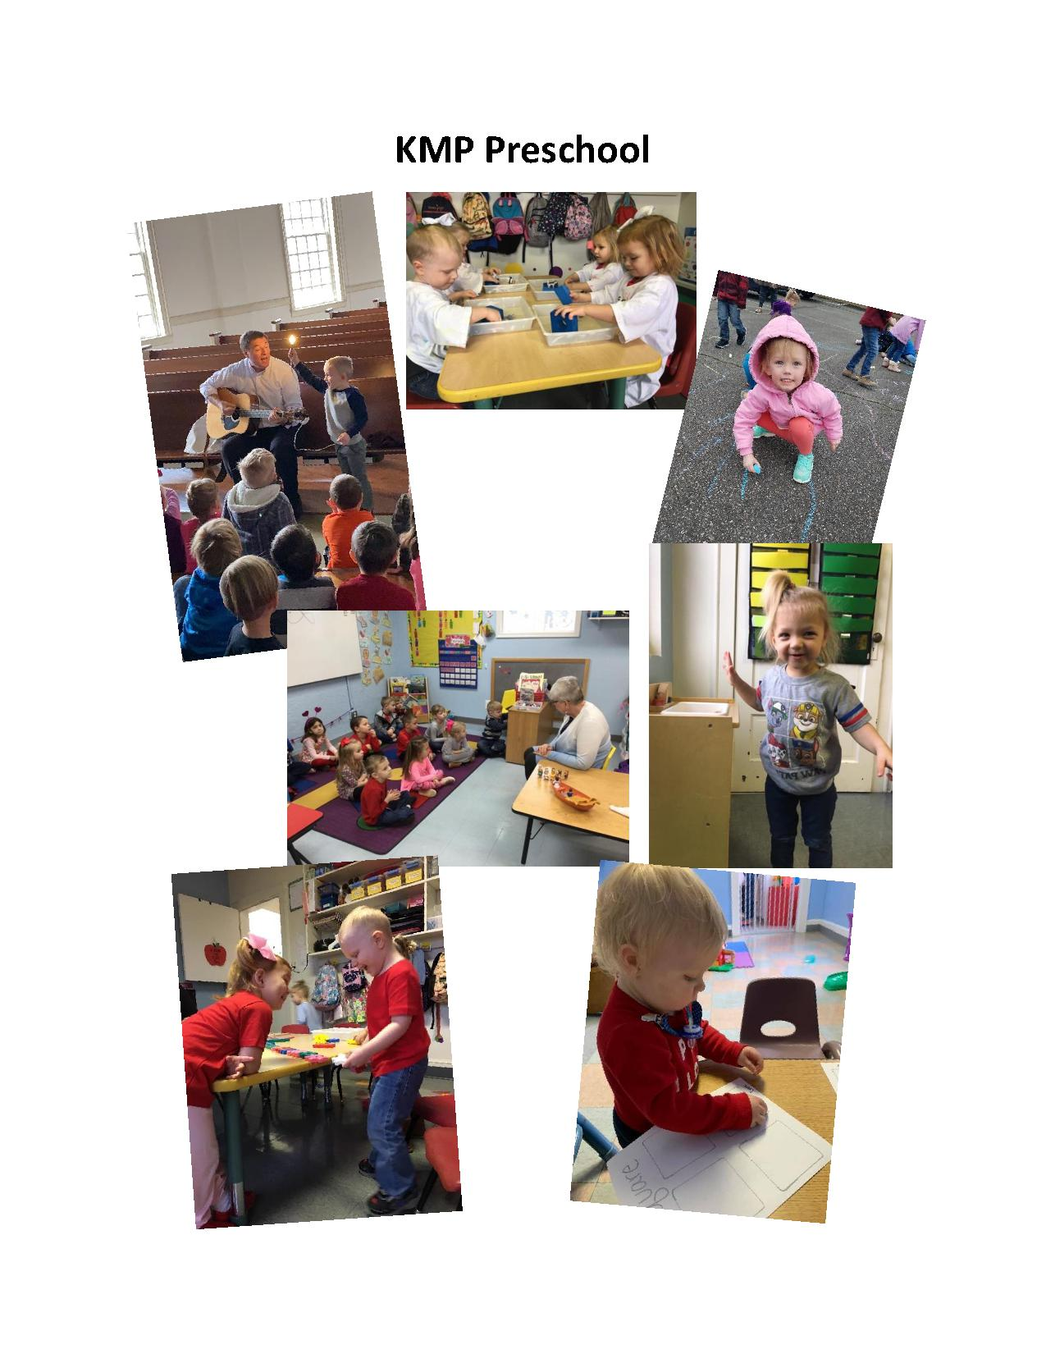PRAYERS FOR CHURCH MEMBERS
Elke Card 136 Hartgrove Rd., King, NC 27021
Henry Bowman 114 Forrest Hills Circle, King, NC 27021
T.W. Carmichael 123 Wellsboro Court, King, NC 27021
Chris Covington 104 Kirkleigh Court, King, NC 27021
Eric Emery
Rachel Falls 1301 Brookstown Ave., Apt.104, Winston-Salem, NC 27101
Martha Hall 114 Brae Creek Court, King, NC 27021
Margie Hall 2131 Nettlebrook Drive, Winston-Salem, NC 27106
Mike and Gina Handy 5600 Folkstone Rd.. Pfafftown, NC 27040
Pat and Anita Johnson 144 Brighton Drive, King, NC 27021
Anita Jones 8600 Jefferson Church, Rural Hall, NC 27045
Joel Kiger 120 Wellsboro Court, King, NC 27021
John Kincaid 1030 Jacob Ridge Rd., Pinnacle, NC 27043
Jerry and Joanne Long 110 Forest Hills Circle, King, NC 27021
Rachel Martin Village Care, 440 Ingram Drive, King, NC 27021
Frank Martin P.O. Box 412. King, NC 27021
Thelma Matthews Heritage Woods Assisted Living, 3812 Forrestgate Dr,
Winston-Salem, NC 27103
Mac Powell 4016 Yarbrough Avenue, Winston-Salem, NC 27106
Dwayne Pratt and Family 114 Guinevere Court, King, NC 27021
Audrey Rubio 607 Samara St., Apex, NC 27502
Stephanie Stewart Allegheny Center, 179 Combs St., Sparta, NC 28675
Willie & Mitzi Thomas 111 Booe St., King, NC 27021

PRAYERS FOR FAMILY AND FRIENDS
Family and Friends of Robert Van Auken Uncle of Hope Campbell
Phil Bloome
Alton Bowen Friend of Corky and Carolyn Newsome
Maxine Bowen Nan Pulliam’s cousin
Tommy Bowman Friend to King Moravian
Peggy Bumgarner Richard and Kristin Smith’s neighbor
Sophie Carter Granddaughter of Sonny and Anna Grubbs
Tim Davis Randy Davis’ brother
Mike Earley Kirt Earley’s son
Doris Gilbert Kim Hill’s mother in law
Bill Lewis Father of Nan Pulliam
Annie, Louis, Zeke, and Kyrie Liss Granddaughter and family of Ray Horner
Karen Luzzi Friend of Amy and Dane Heath
Elizabeth McClellan Mother of Amy Heath
Charles McClellan Father of Amy Heath
Kenneth Moffett Relative of Ed Sipes
Sybil Moore Mother of Terri Lyda
Angela Neve Daughter in law of Daryl and Judy Neve
Virginia Oseguera Mother of Manny Oseguera
Avery Pennell Son of Tiffany and Ryan Pennell
Elynor Rights Mother of Rev. Doug Rights
John C. Rubio, II Son of Audrey Rubio
Brent Sevier Nephew of Ken Sevier
Bentley Shelton Great nephew of Fran Newsom
Bill Smith Uncle of Heather Johnson
Brad Tedder Friend of Ken and Cynthia Sevier
Ken Tedder Friend of Jim and Martha Hall
Pearl Monroe Tucker Daughter of Chad and Meredith Tucker
Donna Wilt Co-worker of Robert Simpson

Please reach out in love to these members with a card, visit or telephone call. To continue a prayer concern for the next month, please contact the office with updates or use the prayer request slips found in the pew racks.
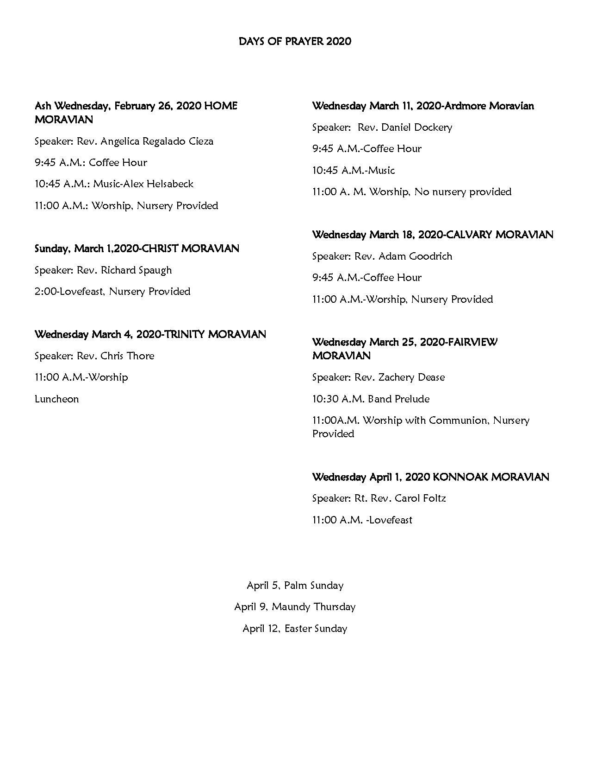
Upcoming Church Events
Mar.1st- 11:00am Communion

Mar.3rd- 6:30pm Finance Committee meeting at the church office

Mar.4th- 5:30pm Middle and Senior High youth backpack project at King Outreach Ministry
5:30-6:00pm 2nd-5th Handbell Group
6:00pm Wednesday Dinner
7:00pm Adult Choir
7:00pm Shepherding Committee meeting

Mar.5th –1:00pm (12:30pm meet at church to carpool) Circle of Help lunch at Providence Restaurant

Mar.7th- 5:00-8:00pm KMP 31 Bingo Fundraiser in fellowship hall

Mar.8th- After worship- Juniors trip to Sci-Works/Kaleideum

Mar.11th- 5:00pm Middle and Senior High youth trip to Dave and Buster’s
5:30-6:00pm 2nd-5th Handbell Group
6:00pm Wednesday Dinner
7:00pm Adult Choir

Mar.15th- After worship- Middle and Senior High youth hosting a lunch for all Senior Friends

Mar.21st- 8:00am Pine Needle Deliver Day- Middle and Senior youth helping spread pine needles- Anyone available to help spread pine needles we would greatly appreciate it!

Mar.22nd- After worship Juniors- Study about Easter

Mar.25th- 5:30-6:00pm 2nd-5th Handbell Group
6:00pm Wednesday Dinner
6:30-7:30pm Middle and Senior High youth meeting at the Youth house
7:00pm Adult Choir

Mar.28th- 8:00am-1:00pm Church Clean Up Day

Mar 8 The Vivaldi Project Trio – Acclaimed period instrument ensemble performing Moravian and non-Moravian music by Antes, Klausek, J.C. Bach, Beethoven; Sunday, March 8, 2020, 3:00 pm, Gray Auditorium, Old Salem Visitors Center, 900 Old Salem Rd., Winston-Salem, NC. Free. https://www.facebook.com/HMCMusicAtHome/ www.thevivaldiproject.org
Mar 8 Beethoven and Friends: History You Can Hear! Concert by the Lititz Moravian Collegium Musicum 7:00pm in Lititz Fellowship Hall, 8 Church Square, Lititz, PA. Dr. Jeffrey Gemmell, Director of Music Ministries. The Collegium features period instruments and the 1787 Tannenberg organ. Tickets are $15/$5 at the door. More info at https://gemmell-posts.com
Mar 12 Lunchtime Lecture Series – Nurturing the Gardeners of Wachovia; the third horticultural exhibit of the Moravian Archives; Eric Elliott, lecturer. Moravian Archives & Moravian Music Foundation present free lectures for the public, held on the 2nd Tuesday of the month, 12:15 p.m. at the Archie K. Davis Center, 457 S. Church St. behind the PEC offices (Cedarhyrst). https://moravianmusic.org/news-and-events/lunchtime-lectures/ 336-722-1742 or 336-725-0651
March 13-15 2020, Music on the Mountain, a Moravian Music Weekend at Laurel Ridge Moravian Camp, Conference, and Retreat Center, Laurel Springs, NC. Choral and band tracks; listeners always welcome! Registration opens fall 2019. Laurel Ridge Camp and Conference, 124 Pendry Dr., Laurel Springs, NC; 336-359-2951 or (888) 831-5922 or info@laurelridge.org Sponsored by the Moravian Music Foundation www.MoravianMusic.org
Apr 9 Lunchtime Lecture Series – Christian Reuter: Moravian GIS Mapper for Forsyth County; Dr. Rod Meyer, former Director, Historic Bethabara Park, lecturer. Moravian Archives & Moravian Music Foundation present free lectures for the public, held on the 2nd Tuesday of the month, 12:15 p.m. at the Archie K. Davis Center, 457 S. Church St. behind the PEC offices (Cedarhyrst). https://moravianmusic.org/news-and-events/lunchtime-lectures/ 336-722-1742 or 336-725-0651
Apr 26 Unitas Chorale in Concert, Sunday, 4:00pm, April 26, 2020; Advent Moravian Church, 3730 Jacksonville Road, Bethlehem, PA
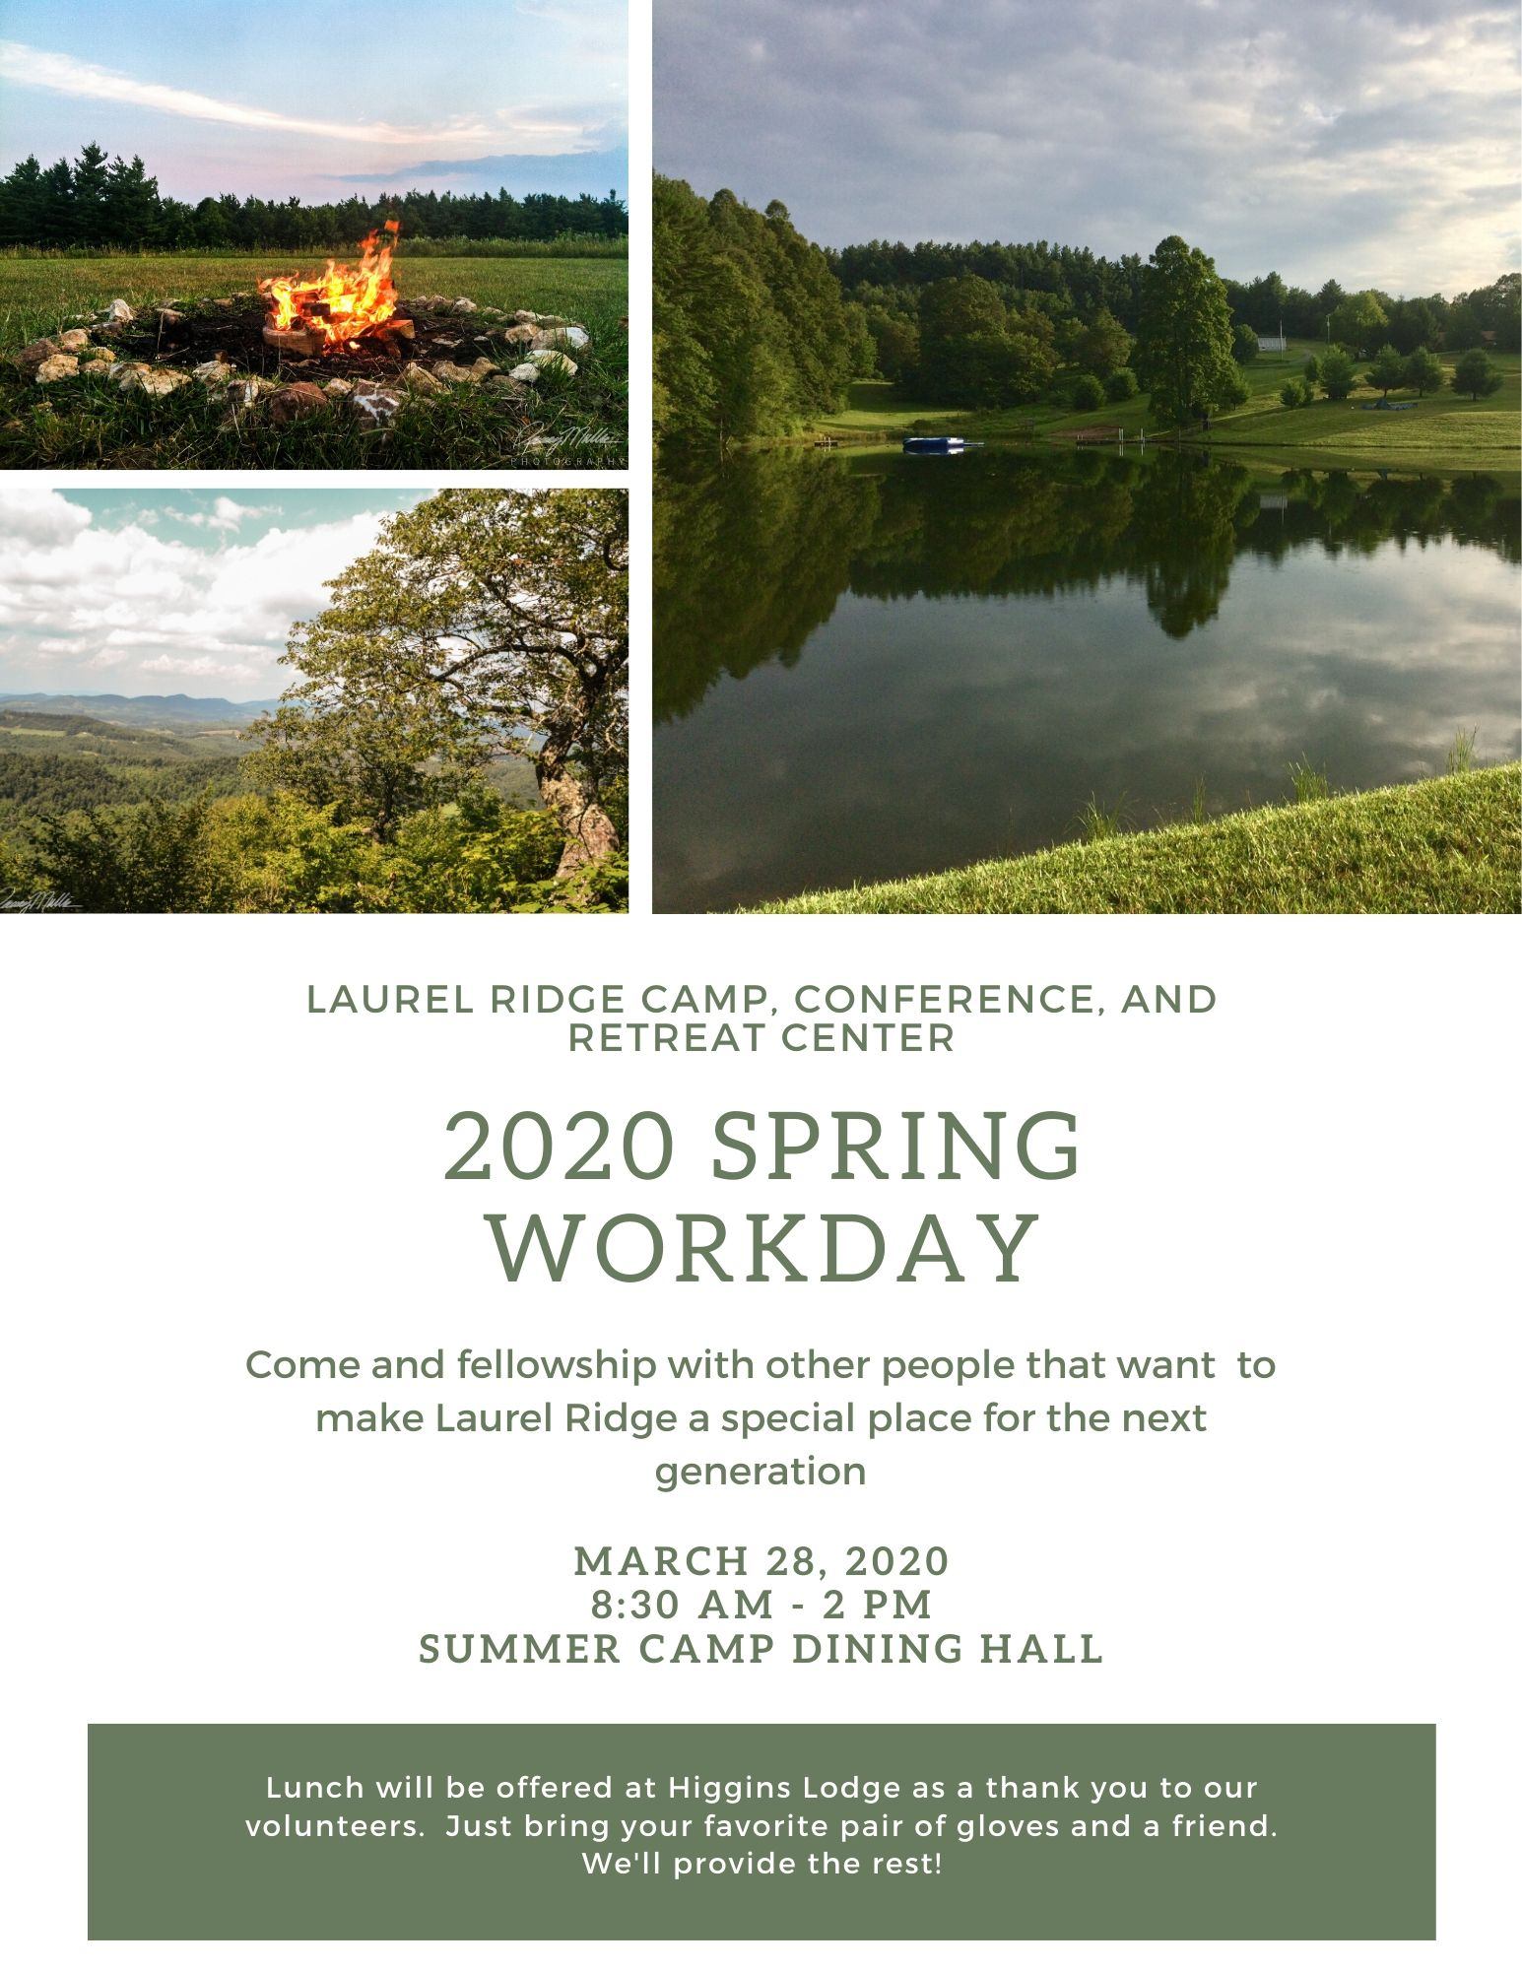 KMC Notes
March 2020

King Moravian Church
228 West Dalton Rd.
King, NC 27021

