October 2022

KMC Notes
Save the Dates …
We hope you will join us for our
Worship Services

Sunday, October 2 (Anniversary Sunday)
Lovefeast and Walk Up Offering

Sunday, October 9 (Worldwide Communion Sunday)
Communion

Sunday, October 16 (Nineteenth Sunday after Pentecost)

Sunday, October 23 (Twentieth Sunday after Pentecost)

Sunday, October 30 (Twenty-first Sunday after Pentecost)

OUR CAPITAL CAMPAIGN IS HERE!
IN ALL THINGS LOVE – RESTORE, RENEW, REJOICE

This month we begin a two-year journey as a church family to raise $500,000 for our building needs and to reach out to our community. This month we begin our Capital Campaigns which starts with our Capital Campaign Dinner on October 1. The purpose of this campaign is to raise funds to replace all of our heating and cooling systems in the church, to replace a roof that has already exceeded its lifespan, to renovate our Picnic Shelter, to update our Youth House, and to have funds available for other building needs. The purpose of this campaign also includes giving ten percent of what we raise to community outreach with funds going to King Outreach Ministries and our Share the Blessing Mission Blitz.

From here we begin our campaign, yet the vision for this campaign began several years ago. For a while now, some of our members have been mindful of the needs of our church facility. For the past two years our Joint Boards have made having a Capital Campaign one of its goals for the year. Our campaign would have started sooner, but COVID kept us from starting it. For the past several months a lot of groundwork for the campaign has been done by our Campaign Steering Committee who consists of Budge Gage, Dane Heath, Desty McEwan, Doug Spainhour and me. Our committee appreciates the contribution of Paula Hall who helped with our campaign brochure. This article shows the cover of our brochure, and here is what Paula wrote for the brochure:

For almost 100 years King Moravian Church has served its congregation well. The church has baptized and confirmed us, married and educated us, and ushered many into the greater presence of our Lord and Savior. As we live out our mission of being “Children of God, Serving Others in the Spirit of Christ,” King Moravian Church has provided us a place to learn, explore, question, grow and celebrate our Christian faith. Yet with an aging facility and deteriorating infrastructure, we have some work to do to ensure that these hallow halls are still serving others for generations to come.
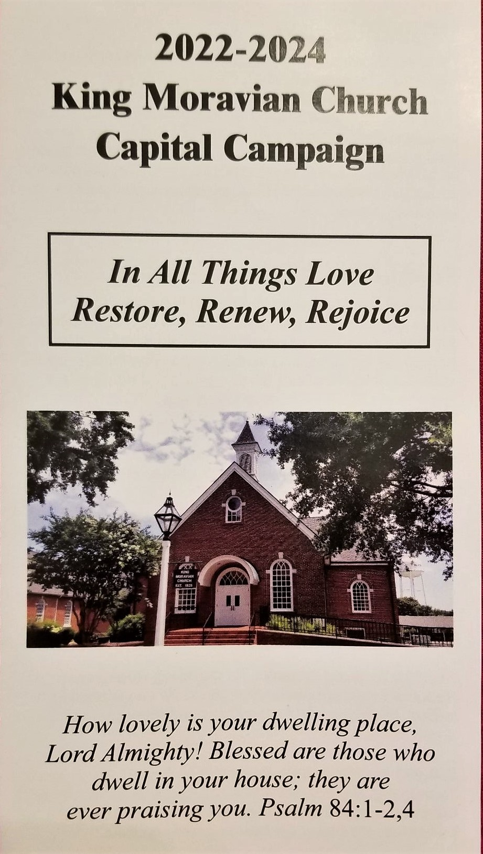
For these next two years, we are asking all of our
members and friends of our church family to prayerfully
consider how you can help our church home. There is
the opportunity for everyone to make a pledge to this
campaign. There will be opportunities to support
fundraisers. May our responses to this campaign be
expressions of our love for God and for all that God
does for us as individuals, as families and as a church
family. May these next two years be yet another way
we can live out part of our Moravian motto, “In all
things love,” as we raise funds to restore what needs
restoring, to renew what needs to be renewed, and as
we do, when we get to our 100th Anniversary, to rejoice!

In Christ’s love and service,
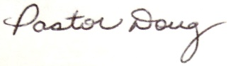

SPECIAL SERVICES IN OCTOBER

ANNIVERSARY SUNDAY – SUNDAY, OCTOBER 3
Our church family will celebrate its 98th Anniversary on Sunday, October 2. We hope all who are able to come will be with us for this special day in the life of our church family. Our service will include sharing a lovefeast.

WALK UP OFFERING – SUNDAY, OCTOBER 2
On Sunday, October 2, we will have our Walk Up Offering for King Outreach Ministry. During the offering everyone is invited to come forward with their offering for our General Fund and their offering for King Outreach Ministry.

MISSION BLITZ
FRIDAY, OCTOBER 7 – SUNAY, OCTOBER 9
Our Mission Blitz is Friday, October 7, to Sunday, October 9. If you would like to serve on one of the work teams, please turn in a Volunteer Form. We are also taking donations for anyone who would like to help cover the cost of our Mission Blitz. One way is to take an envelope off our Wall of Money and give the amount on the envelope.
If you have any questions about Mission Blitz, please contact anyone of our Share the Blessing Committee who are Rachael Butts, Paula Hall, Desty McEwan, Amy Reeves, Ken Sevier, Robert Simpson, Zollie and Renee Smith, and Doug Rights.

**Share The Blessing Special Announcement**
We received a $2,000 grant from the Housing and Shelter Fund from The Moravian Ministries Foundation! This money will be used for lumber and supplies for Mission Blitz!
THANK YOU MMFA!!!

WEDNESDAY NIGHT DINNERS
WEDNESDAY, OCTBER 12 and WEDNESDAY, OCTOBER 26
Last month we resumed our Wednesday Night Dinners. Thank you to everyone who came to the dinners and we thank the Circle of Hope and our Board of Elders who provided the meals. Our Wednesday Night Dinners are the second and fourth Wednesdays of the month. This month they will be help on Wednesday, October 12 and Wednesday, October 26. The dinners begin at 6:00 p.m. Everyone is invited to attend.
At this time we are looking for groups or individuals who would like to provide the meals. For those coming to the dinners, we ask that you make a donation for the meal. The group that does the meal will decide how the money will be used. For any group that would like to provide a meal, please contact Holly Mathis or call the church office.

MEN’S BREAKFAST
SUNDAY, OCTOBER 16
All of our men are invited to our next Men’s Breakfast which will be on Sunday, October 16, at 8:30 a.m. in the Fellowship Hall. We have our Men’s Breakfast on the third Sunday of the month, and we have had a good group at each of the breakfasts the past couple of months. There will be a sign up sheet at the church which we encourage those coming to sign so we know how many to plan for.

CHURCH PICNIC
SUNDAY, OCTOBER 16
We had planned to have our Church Picnic this past month, but we rescheduled it due to the threat of bad weather. The new date for our Church Picnic is Sunday, October 16. It starts at 6:00 p.m. We appreciate everyone who signed up to bring items and to help with this event. For those who might be unable to bring what they signed up for or are unable to help, please call the church office and let us know. We hope to have a lot of people with us to share in this great time of good food and good fellowship.

PRESCHOOL HALLOWEEN CARNIVAL
SUNDAY, OCTOBER 30
Our Preschool is having its Halloween Carnival on Sunday, October 30, which will be in the afternoon from 2:00 p.m. until 5:00 p.m. Something our Preschool would like to add to this year’s Carnival is a Trunk or Treat. If anyone would like to decorate their vehicle and provide treats for those who come see your decorations, please contact our Preschool Director, Tina Pratt, or call the church office.

AND COMING IN NOVEMBER

CHURCH COUNCIL – SUNDAY, NOVEMBER 13
NOMINEES FOR CHURCH BOARDS
We will have our annual Church Council meeting the second Sunday in November. We are looking for anyone interested in being a nominee for our Board of Elders and Board of Trustees. If you feel led be a nominee for either board or Synod, please contact anyone from our Nominating Committee who are Candice Covington, Sue Donathan, Budge Gage, Doug Gordon, Gina Handy, or Doug Spainhour.

CHURCH FAMILY NEWS

Our church family extends its Christian love and sympathy to the family and friends of Mac Powell who passed away on September 14, and to the family and friends of Thelma Matthews who passed away on September 20.

In the hospital since our last newsletter has been Gina Handy.

SPECIAL WORDS OF THANKS

We were very thankful on Sunday, September 4, when we dedicated our livestream equipment. Special thanks to the late Roger Cooke for his very generous donation to our church family which helped cover the cost of the equipment. We also thank our Audio/Visual Team for their work in getting the equipment. Those serving on the team are Jacob Bullin, Rachael Butts, Sophie Jennings, Ken Lyda, Doug Spainhour and Doug Rights.

We thank everyone who donated either money or supplies for our September Walk Up Offering that went to our Preschool.

We thank our Director of Music, Drake Flynt, and our Choir for the special and inspiring Music Sunday they share on Sunday, September 11.

We thank our Board of Elders for the Movie Night they provided on Saturday, September 17. We didn’t have many attend, yet those who did had a great time!
We thank the Rev. Steve Craver for his help in leading the service and sharing the message on Sunday, September 25. We also thank Desty McEwan for her help in leading the service.

SOME YOUTH FELLOWSHIP NEWS

PICTURES FROM THE SENIOR HIGH AND MIDDLE HIGH YOUTH RETREAT
AT LAUREL RIDGE

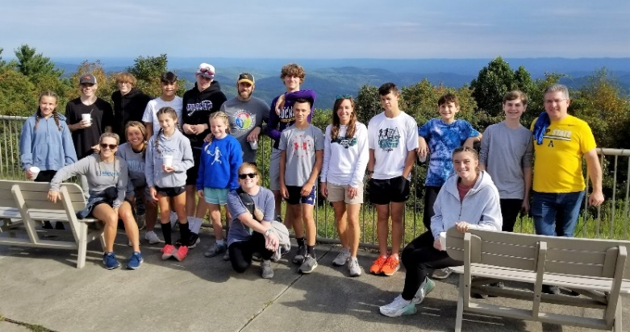
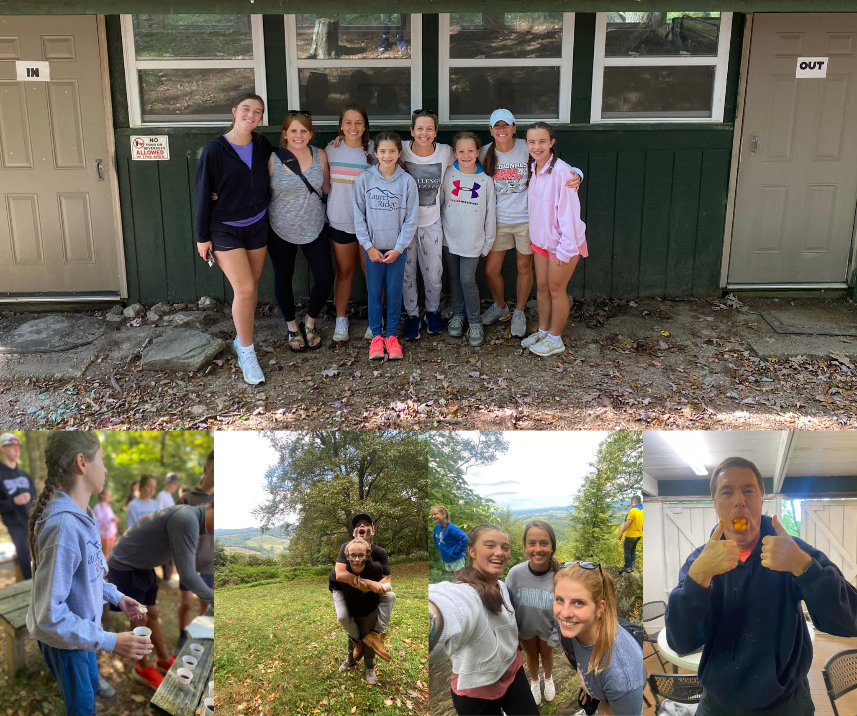

Senior High and Middle High Schedule

October 9th Mission Blitz project. Meet at the Youth House at 10:00 a.m.

October 12th Wednesday Night Dinner at the church at 6:00 p.m. followed by
coffee at Fannie and Ira’s.

October 15th go to the Spooky Corn Maze.

October 26th Wednesday Night Dinner at the church at 6:00 p.m. followed by
coffee at Fannie and Ira’s.

October 30th help with the Preschool Carnival anytime from 12:00 noon to 5:00 p.m.
Junior Youth Group Schedule

October 14th at 6:30 (youth house) Campfire and camp songs
Dinner is provided

October 30th after church we will have lunch and then go reverse trick-or-treating at Priddy Manor. Please bring your costume to change into after church. When we return from Priddy Manor, we encourage you and your family to stay for the Preschool Halloween Carnival!

SOME PRESCHOOL NEWS

A couple of our awesome Library Buddies on Wednesday. Pastor Doug Rights and Pastor Gerald Jones! If you can give 30 minutes occasionally (we go every other week on Tuesday & Wednesday), let Tina know! We would love to have you join us!
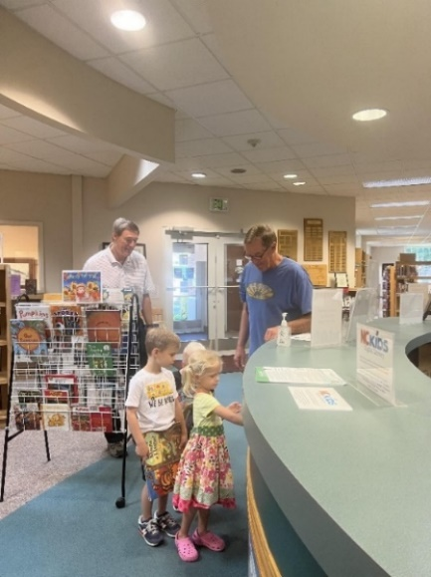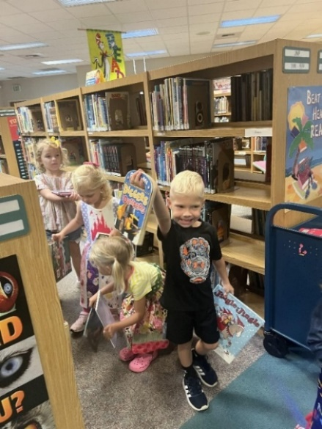

From Left: Jennifer Burge & Desty McEwan's granddaughters painting in Ms. Meredith's class; Arlo Earley enjoying his first week at preschool; Leila and Will's mom brought goats from their farm for the kids to pet and feed.

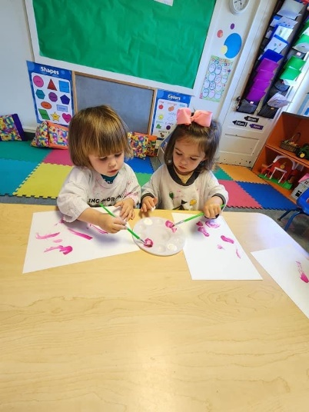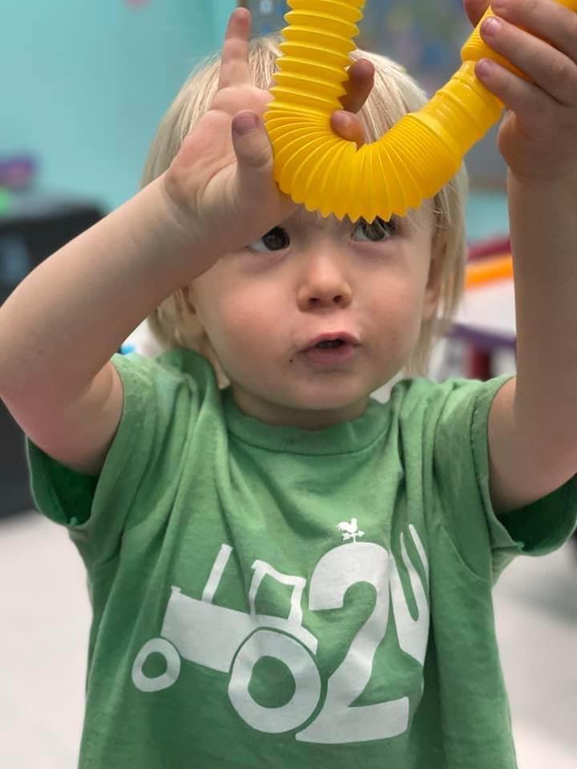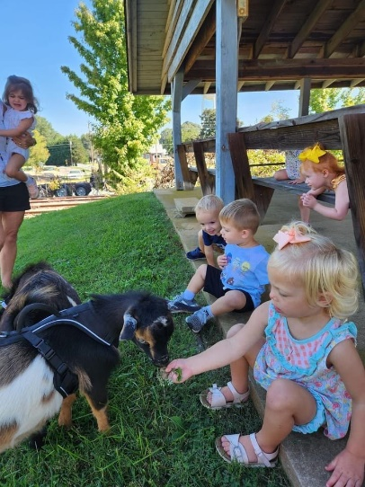

CHURCH SCHEDULE FOR OCTOBER

October 1 Capital Campaign Dinner at 6:00 p.m.

October 2 Worship Service at 11:00 a.m. (Anniversary Sunday)
Walk Up Offering and Lovefeast

October 5 Adult Choir – 7:00 p.m.

October 7-9 Mission Blitz

October 9 Worship Service at 11:00 a.m. (Worldwide Communion
Sunday)

October 11 Joint Board Meeting – 6:30 p.m.

October 12 Wednesday Night Dinner – 6:00 p.m.
Adult Choir – 7:00 p.m.

October 14 Juniors – Campfire and S’mores 6:30-8 p.m. (Youth House)

October 16 Worship Service at 11:00 a.m.
Church Picnic at 6:00 p.m.

October 23 Worship Service at 11:00 a.m.
October 26 Wednesday Night Dinner – 6:00 p.m.
Adult Choir – 7:00 p.m.

October 30 Worship Service at 11:00 a.m.
Juniors – Lunch and Reverse Trick-or-Treat at Priddy
Manor
KMP Halloween Carnival 2:00 p.m. to 5:00 p.m.

Financials

Offerings received through September 30: $246,270
Budget expenses through September 30: $266,805
2021 monthly contribution for shared Moravian Church Ministries: $4,826 per month has been paid through September.

CHURCH GIVING
We appreciate all gifts that are given for the ministry of our church family. There are several ways which you can give your gifts which are the following:
● You can bring your contributions to our worship services.
● You can mail your contribution to the church at King Moravian Church, 228 W. Dalton
Road, King, NC 27021.
● You can bring your contribution to the church office and deposit it in the slot in the security
box affixed to the wall outside the office door.
● You can give online. Go to our church’s website (www.kingmoravianchurch.org) and click
and click on the “Online Giving” link which will take you to our King Moravian Church
Donation Form through the Moravian Ministries Foundation.
October Birthdays
1 – Holly Mathis  1 – Eirik Oseguera  3 – Erin Allgood  3 – Diana Hoffman  3 – Zeb Mathis  4- Ed Deal  4 – Bill Hall  4– Corky Newsome  4- Gary Monteith  4 – Zollie Smith  5 – Annette Covington  5- Louisa Covington  5- Karen Gordon  8- Don Elliott  8- Bill Pulliam  9- Gina Handy  9- Tom Tomchik  10- Renee Smith  10 – Susan Sullivan  10- Carol Weatherbee  11- Nate Sapp  11- Russell Sapp | 12- Tommy Reeves  13- Mark Johnson  15- Brody Shore  18- Kim Hill  19- Tina Pratt  19- Scarlett Smith  20- Liam Grubbs  21- Mallory Finn  21- Naomi Stevens  22- Danny Young  22- Sara Russell  24- Margie Hall  24- Beth Easter  25-Ann Deal  26- Sam Hall  27- Darrell Goins  27- John New  28- Kelly Nickell  29-Paul Horner  31-Liz Hensley  31-Natalie Durham

Pray Every Day October 2022

- Blessed are the poor in spirit, for theirs is the kingdom of heaven. Pray for Ukrainian refugees and the Moravian response in the Czech Republic.
- Rejoice and be glad, because great is your reward in heaven, for in the same way they persecuted the prophets who were before you. Pray for Michael and Naomi Woo and their missionary leadership course.
- You are the light of the world. A city on a hill cannot be hidden. Pray for disaster relief workers and Moravian Disaster Response.
- Ask and it will be given to you; seek and you will find; knock and the door will be opened to you. Pray for Michael and Brenda Brent in Croatia.
- But seek first his kingdom and his righteousness and all these things will be given to you as well. Pray for Louis and Susan Sutton in Singapore.
- The harvest is plentiful but the workers are few. Ask the Lord of the harvest, therefore, to send out workers into his harvest field. Pray for Charlie and Vicki Brent in Texas.
- As you go, preach this message: “The kingdom of heaven is near.” Pray for the government leaders and unity in our country.
- Whoever finds his life will lose it, and whoever loses his life for my sake will find it. Pray for short term mission teams.
- Come to me all you who are weary and burdened, and I will give you rest. Pray for Safiatu Braima and Sierra Leonne.
- Make a tree good and its fruit will be good, or make a tree bad and its fruit will be bad, for a tree is recognized by its fruit. Pray for seminarians and candidates for ordination.
- For whoever does the will of my Father in heaven is my brother and sister and mother. Pray for the Moravians in Peru.
- If anyone would come after me, he must deny himself and take up his cross and follow me. Pray for the Clinica Evangelica Morava in Ahaus.
- I tell you the truth, unless you change and become like little children, you will never enter the kingdom of heaven. Therefore, whoever humbles himself like this child is the greatest in the kingdom of heaven. Pray for Moravians in Cuba and the Armando Rusindo Foundation.
- Love the Lord your God with all your heart and with all your soul and with all you mind. Pray for PEC members, bishops, and other church leaders.
- For whoever exalts himself will be humbled, and whoever humbles himself will be exalted. Pray for Moravians in Honduras and Nicaragua.
- I till you the truth, whatever you did for one of the least of these brothers and sisters of mine, you did for me. Pray for the Raipur Foster Child Project.
- The kingdom of God is near. Repent and believe the good news! Pray for the Teshes in Kenya and Ray of Hope.
- It is not the healthy who need a doctor, but the sick. I have not come to call the righteous, but sinners to repentance. Pray for Phil and Eunice Raiford in Mexico.
- You see, at just the right time, when we were still powerless, Christ died for the ungodly. Pray for Robert and Anne Thiessen.
- For the wages of sin is death, but the gift of God is eternal life in Christ Jesus our Lord. Pray for Adopt-a-Village in Tanzania.
- Therefore there is now no condemnation for those who are in Christ Jesus, because through Christ Jesus the law of the Spirit of life set me free from the law of sin and death. Pray for the Sineaths in Campus Outreach.
- And we know that in all things God works for the good of those who love him, who have been called according to his purpose. Pray for the Unity Women’s Desk.
- I will have mercy on whom I have mercy and I will have compassion on whom I have compassion. Pray for the Hoffmans in HIV/AIDS ministry.
- That if you confess with your mouth, “Jesus is Lord,” and believe in your heart that God raised him from the dead, you will be saved. Pray for Steve and Ann Marx with Mission Aviation Fellowship.
- Love must be sincere. Hate what is evil; cling to what is good. Pray for Kevin and Charity in the Middle East.
- As surely as I live, says the Lord, every knee will bow before me; every tongue will confess to God. Pray for Dusty and Christin Harrison with Greek Intervarsity.
- May the God of hope fill you with all joy and peace as you trust in him, so that you may overflow with hope by the power of the Holy Spirit. Pray for Brian and Heather Marx with Mission Aviation Fellowship.
- For I resolved to know nothing while I was with you except Jesus Christ and him crucified. Pray for Alan and DeeDee Iobst in France.
- For we are God’s fellow workers; you are God’s field, God’s building. Pray for Annie B Missions and Star Mountain.
- Salt is good, but if it loses its saltiness, how can you make it salty again? Have salt in yourselves, and be at peace with each other. Pray for the Board of World Mission.
- Whoever wants to become great among you must be your servant, and whoever wants to be first must be slave of all. Pray for Estamos Unidos Moravian Ministry.
KMC Notes
October 2021
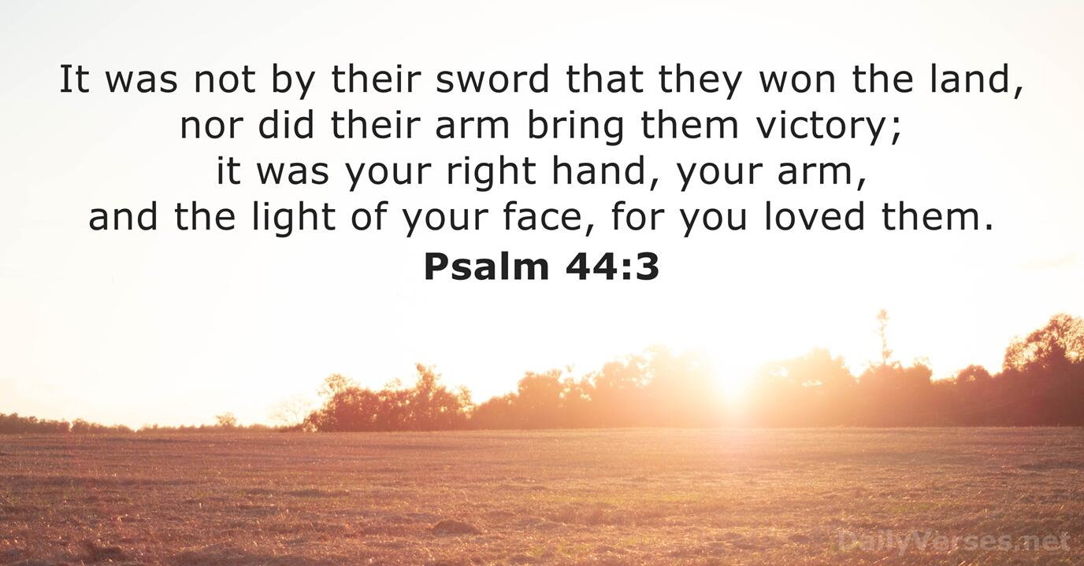

King Moravian Church
228 West Dalton Rd.
King, NC 27021

